CERTIFICATE

***REMARKS:***

**Practical In Charge Associate Director**

### INDEX

|  |  |  |
| --- | --- | --- |
| **Practical No.** | **Problem Statement** | **Date** |
| 1 | HDFS:ListofCommands(mkdir,touchz,copyfromlocal/put,copytolocal/get,movefroml ocal,cp,rmr,du,dus,stat) | 25/9/2023 |
| 2 | MapReduce:   1. Write aprograminMapReduceforWordCountoperation. 2. Write aprograminMapReduceforUnionoperation. 3. Write a programinMapReduceforIntersectionoperation. 4. Write aprograminMapReduceforGroupingandAggregation. 5. WriteaprograminMap Reduce forMatrixMultiplication. | 9/10/2023 |
| 3 | MongoDB:   1. Installation 2. SampleDatabaseCreation 3. QuerytheSampleDatabaseusingMongoDBqueryingcommands    1. CreateCollection    2. InsertDocument    3. QueryDocument    4. DeleteDocument    5. Indexing | 09/10/2023 |
| 4 | Hive:   1. HiveDataTypes 2. Create Database&Table in Hive 3. HivePartitioning 4. HiveBuilt-InOperators 5. HiveBuilt-InFunctions 6. HiveViewsandIndexes 7. HiveQL:SelectWhere,Select OrderBy, Select GroupBy,SelectJoins | 16/10/2023 |
| 5 | Pig:   1. Pig LatinBasic 2. PigDataTypes, 3. Downloadthedata 4. CreateyourScript 5. SaveandExecutetheScript 6. Pig Operations: Diagnostic Operators, Grouping and Joining, Combining &Splitting,Filtering,Sorting | 30/10/2023 |
| 6 | Spark:   1. DownloadingDataSetandProcessingitSpark 2. WordCountinApacheSpark. | 11/12/2023 |
| 7 | VisualizationusingTableau: Tableau:ToolOverview,ImportingData,AnalyzingwithCharts,CreatingDashboards,working withmaps,TellingStorieswithtableau. | 13/12/2023 |

**Practical1**

**Aim:**SetupandConfiguration HadoopusingCloudera.**Theory:**

HDFS is the primary or major component of the Hadoop ecosystem which is responsible for storinglargedatasetsofstructuredorunstructureddataacrossvariousnodesandtherebymaintainingthemetadatain theformoflogfiles.TheFileSystem(FS)shellincludesvariousshell-likecommandsthatdirectlyinteractwith the Hadoop Distributed File System (HDFS) as well as other file systems that Hadoop supports,suchasLocalFS,WebHDFS,S3FS,andothers.

HadoopCommands:

1. mkdir
   * Command:hdfsdfs-mkdir
   * Use:CreateadirectoryunderHadoopfilesystem

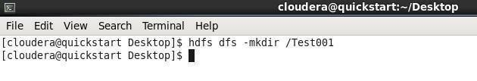

### touchz

* Command:hdfsdfs–touchz
* Use: Createafilenamed underHadoopFileSystem

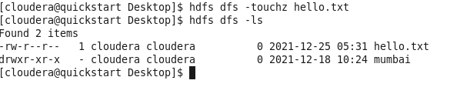

### copyFromLocal/put

* Command:hdfsdfs-copyFromLocal
* Use:Copy filesfromlocalfilesystemtoHadoopfile system

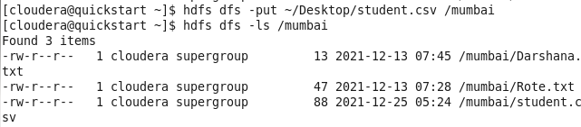

1. **copyToLocal/get** *•*Command:hdfsdfs-copyToLocal
   * Use:Copyfilesfromhadoopfilesystemtolocalfilesystem



### cp

* Command:hdfsdfs-cp
* Use:CopyfilesfromonedirectorytoanotherdirectorywithintheHDFS.

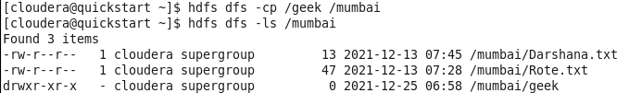

### Rmr

* + Command: hdfsdfs–rm-r
  + Use:Removesthefileordirectoryidentifiedbypath.



### Dus

* Command:hdfsdfs–du–s
* Use:Printsasummary ofdiskusage of allfiles/directoriesin thepath.



### Stat

* Command:hdfsdfs–stat
* Use:Printsinformation aboutpath.

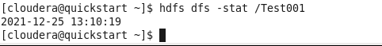

**Practical- 02Aim:**PerformMapReduceAlgorithmPrograms**Description:**

WhatisMapReduce?

MapReduceisaprogrammingparadigmthatenablesmassivescalabilityacrosshundredsortho usandsofserversinaHadoopcluster.Astheprocessingcomponent,MapReduceistheheartof Apache Hadoop. The term "MapReduce" refers to two separate and distinct tasks that Hadoopprogramsperform.

The first is the map job, which takes a set of data and converts it into another set of data, whereindividual elements are broken down into tuples (key/value pairs). The reduce job takes the output from amapasinputandcombinesthosedatatuplesintoasmallersetoftuples.AsthesequenceofthenameMapRed uceimplies, thereducejobisalwaysperformedafterthemapjob.MapReduceprogrammingoffersseveralbenefitstohelpy ougainvaluableinsightsfromyourbigdata:

* + Scalability. Businesses canprocesspetabytesofdata storedin theHadoopDistributedFileSystem(HDFS).
  + Flexibility.Hadoopenableseasieraccesstomultiplesourcesofdataandmultipletypesof data.
  + Speed.Withparallelprocessingandminimaldatamovement,Hadoopoffersfastproce ssingofmassiveamounts of data.
  + Simple.Developerscanwritecodeinachoiceoflanguages,includingJava,C++andPython.Inourcas ewe’lluseJavaasprogramminglanguageandpysparkforsomeotheroperations.Staytuned.

**Program1:**MapReduceforAverageWordCount

Ineclipsecreate 3javaclassesandaddexternaljarinsidefilesystem>usr>lib>Hadoopandclient>

### Codes:

WordCountDriver.java import

org.apache.hadoop.conf.Configuration; importorg.apache.hadoop.fs.Path;

import

org.apache.hadoop.io.IntWritable; importorg.apache.hadoop.io.Text;

import

org.apache.hadoop.mapreduce.lib.output.FileOutputFormat;importo rg.apache.hadoop.mapreduce.Job;

import org.apache.hadoop.mapreduce.lib.input.FileInputFormat; publicclassWordCountDriver{

publicstaticvoidmain(String[]args)throwsException

{ Job j1 = Job.getInstance(newConfiguration());

j1.setJarByClass(WordCountDriver.class);j1.setJobName("Average

Word Count");

FileInputFormat.addInputPath(j1, new

Path(args[0]));FileOutputFo

rmat.setOutputPath(j1, new Path(args[1]));j1.setMapper

Class(WordCountMapper.class);j1.setReducerClass(WordCountRe ducer.class);j1.setOutputKeyClass(Text.class);j1.setOutputValueCl ass(IntWritable.class);System.exit(j1.waitForCompletion(true)?0:1);

}

}

WordCountMapper.java

importjava.io.IOException;imp ortjava.util.StringTokenizer;

import org.apache.hadoop.io.IntWritable; importorg.apache.hadoop.io.LongWritable; importorg.apache.hadoop.io.Text; importorg.apache.hadoop.mapreduce.Mapper;

public class WordCountMapper extends Mapper<LongWritable, Text, Text, IntWritable>{ private final staticIntWritableone=newIntWritable(1);

private Text word = new Text();@Override

protectedvoidmap(LongWritablekey,Textvalue,Mapper<LongWritable, Text,Text,IntWritable>.Contextcontext)throwsIOException,InterruptedEx ception{

Stringline=value.toString(); StringTokenizeritr=newStringTokenizer(line);while (itr.hasMoreTokens()){

word.set(itr.n

extToken()); context.write(word,one);

}

}

}

WordCountReducer.javaimport

java.io.IOException; import

org.apache.hadoop.io.IntWritable; importorg.apache.hadoop.io.Text;

importorg.apache.hadoop.mapreduce.Reducer; publicclassWordCountReducerextendsReducer<Text,IntWritable,Text,IntWritable>

{@Override protectedvoidreduce(Textkey,Iterable<IntWritable>values,Reducer<Te xt,IntWritable,Text,IntWritable>.Contextcontext)throwsIOException,Interr uptedException{

intsum=0;

for(IntWritable value

:values){sum+=val

ue.get();

}

context.write(key,newIntWritable(sum));

}

}

Afterthistypedownthesecommands

### Output:

* + - ls
    - geditwordcountinput
    - hadoopfs-touchzwordcountinputhdfs

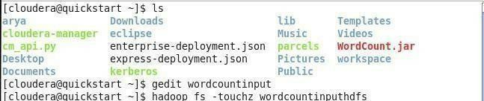

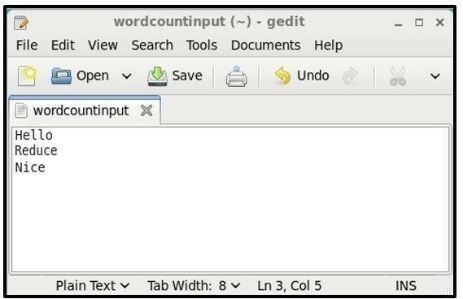

* + - hadoopfs-copyFromLocalwordcountinput/wordcountinputhdfs
    - hdfsdfs-cat/wordcountinputhdfs

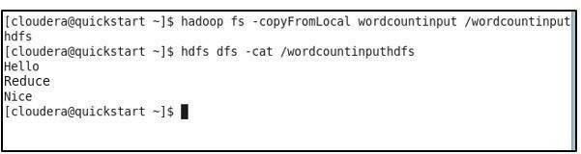

* + - hdfsdfs-mkdirwordcountoutputhdfs



* + - hadoopjarWordCount.jarWordCountDriver/wordcountinputhdfs

/wordcountoutputhdfs

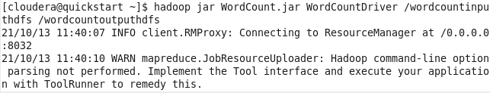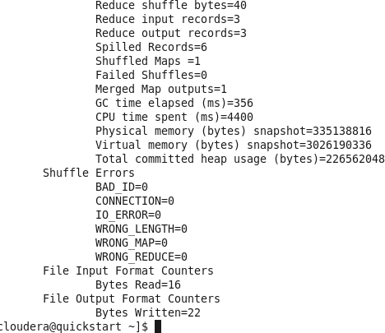

* + - hdfsdfs-cat/wordcountoutputhdfs/part-r-00000

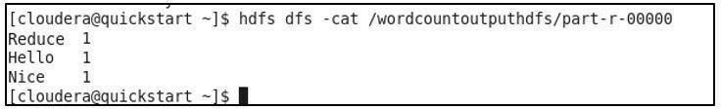

### CommandsforUnionIntersectionOperations:

1. **Join()**

>>x=sc.parallelize([("spark",1),("hadoop",4)])

>>y=sc.parallelize([("spark",2),("hadoop",5)])

>>joined=x.join(y)>>final=joined.collect()

>>print"JoinRDD->%s"%(final)

### union

**(a)**

>>>frompysparkimportSparkContext

>>>sc=SparkContext()

>>>sqlContext=SQLContext(sc)

>>>valuesB=[('abc',1),('pqr',2),('mno',7),('xyz',9)]

>>>TableB= sqlContext.createDataFrame(valuesB,['name','customerid'])

>>>valuesC=[('abc',1),('pqr',2),('mno',7),('efg',10),('hik',12)]

>>>TableC=sqlContext.createDataFrame(valuesC,['name','customerid']

>>result=TableB.unionAll(TableC) >>>result.show()

### (b)

>>>s=sc.parallelize([1,2,3,4,5,6])

>>>r=sc.parallelize([4,5,6,7,8,9,10])

>>>uni=s.union(r)

>>>uni.collect()

1.Intersection()

>>>frompysparkimportSparkContext

>>>sc=SparkContext()

>>>sqlContext=SQLContext(sc)

>>>valuesB=[('abc',1),('pqr',2),('mno',7),('xyz',9)]

>>>TableB= sqlContext.createDataFrame(valuesB,['name','customerid'])

>>>valuesC=[('abc',1),('pqr',2),('mno',7),('efg',10),('hik',12)]

>>>TableC=sqlContext.createDataFrame(valuesC,['name','customerid']

>>result=TableB.intersect(TableC)

>>>result.show()

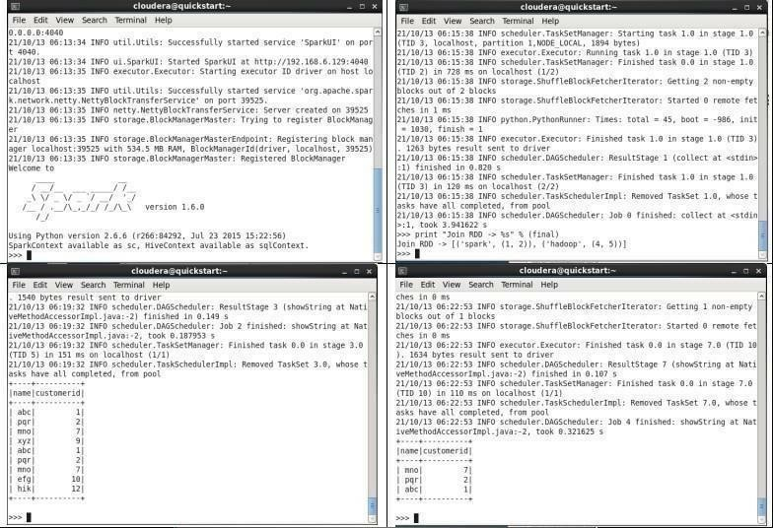

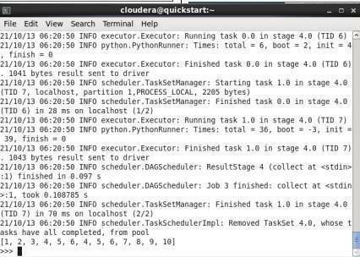

**Conclusion:**SuccessfullyPerformedMapReduceProgramsinClouderaVMusingJavaandPySp ark.

**Practical - 03Aim:**ToinstallandexecuteMongoDBcommands.

**Theory:**

### MongoDB–

MongoDBisadocument-orientedNoSQLdatabaseusedforhighvolumedatastorage.Insteadofusingtables and rows as in the traditional relational databases, MongoDB makes use of collections anddocuments. Documents consist of key-value pairs which are the basic unit of data in MongoDB.Collectionscontainsetsofdocumentsandfunctionwhichistheequivalentofrelationaldatabaseta bles.MongoDBisadatabasewhichcameintolightaroundthemid-2000s.

**MongoDBFeatures-**

1. Each database contains collections which in turn contains documents. Each document can bedifferent with a varying number of fields. The size and content of each document can bedifferentfromeachother.
2. The document structure is more in line with how developers construct their classes and objects intheirrespectiveprogramminglanguages.Developerswilloftensaythattheirclassesarenotrowsandcolu mnsbuthaveaclearstructurewithkey-valuepairs.
3. Therows(ordocumentsascalledinMongoDB)doesn’tneedtohaveaschemadefinedbefore hand.Instead,thefieldscanbecreatedonthefly.
4. The datamodelavailablewithinMongoDBallowsyouto representhierarchicalrelationships, tostorearrays,andothermorecomplexstructuresmoreeasily.
5. Scalability – The MongoDB environments are very scalable. Companies across the worldhavedefinedclusterswithsomeofthemrunning100+nodeswitharoundmillionsofd ocumentswithin thedatabase

**MongoDBExample**- ThebelowexampleshowshowadocumentcanbemodelledinMongoDB.

1. The_idfieldisaddedbyMongoDBtouniquelyidentifythedocumentinthecollection.
2. WhatyoucannoteisthattheOrderData(OrderID,Product,andQuantity)whichinRDBMSwill normally be stored in a separate table, while in MongoDB it is actually stored as anembeddeddocumentinthecollectionitself.Thisisoneofthekeydifferencesin how dataismodelled in MongoDB.

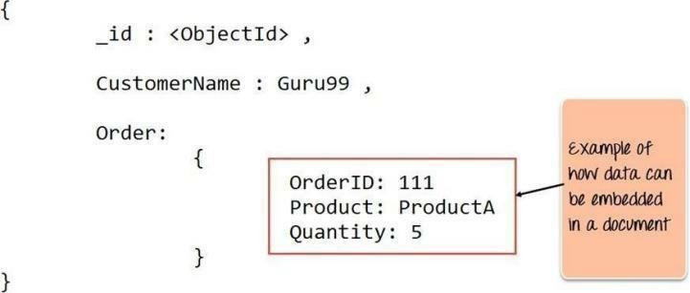

1. **Installation:**

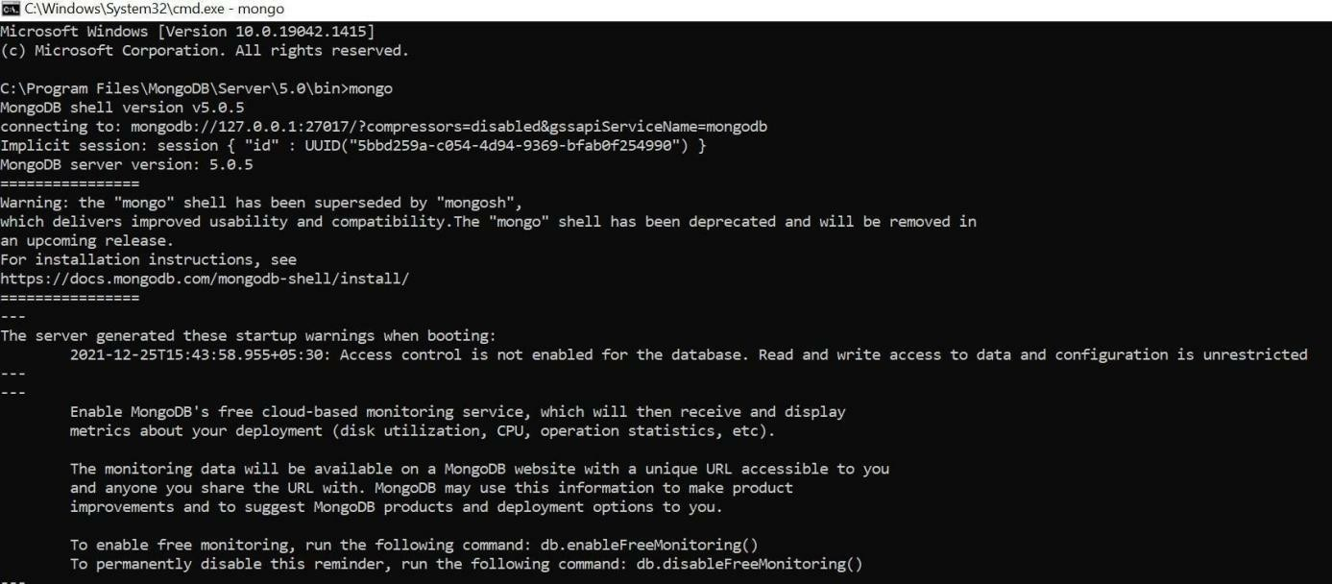

1. **SampleDatabaseCreation:**

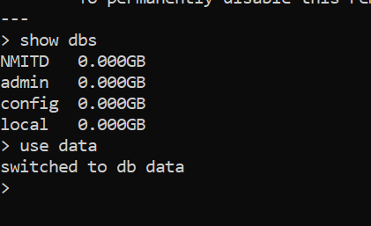

1. **QuerytheSampleDatabaseusingMongoDBqueryingcommands:**
   1. **CreateCollection**

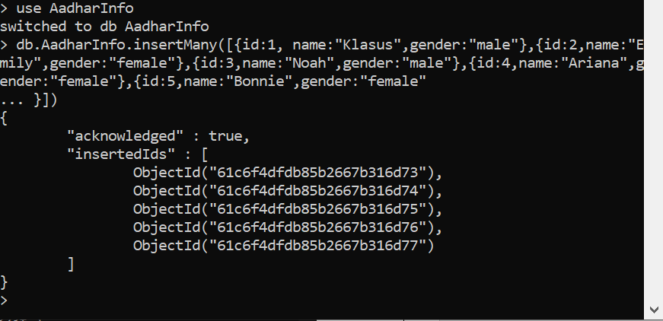

* 1. **InsertDocument**

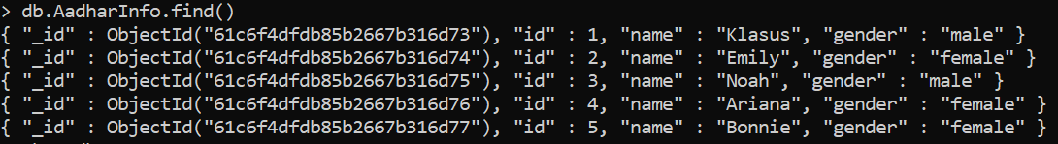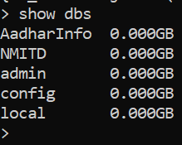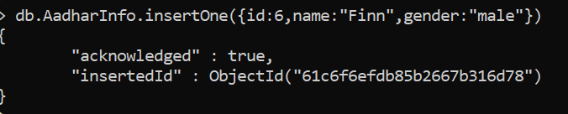

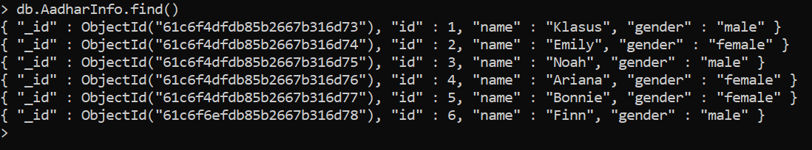

* 1. **QueryDocument**

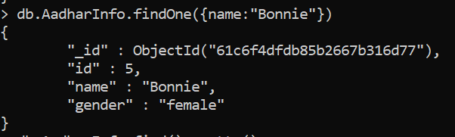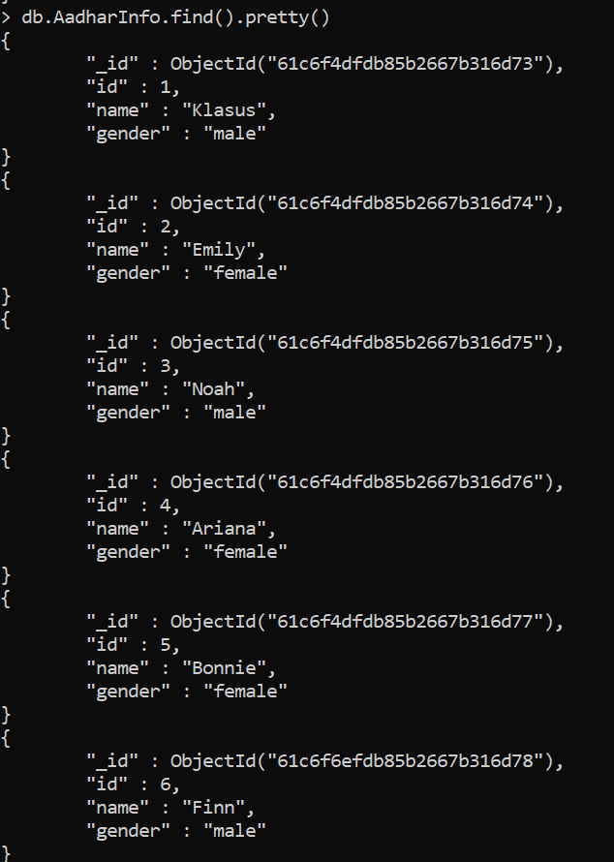

* 1. **DeleteDocument**

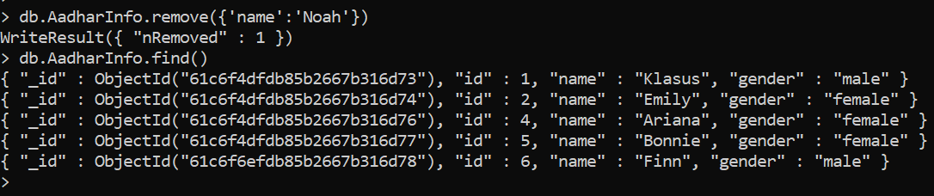

**Update**

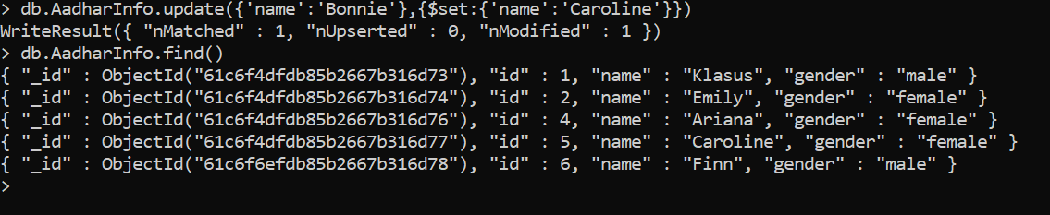

* 1. **Indexing**

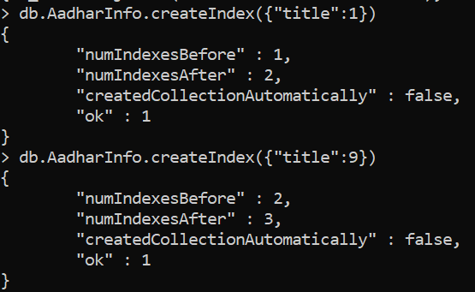

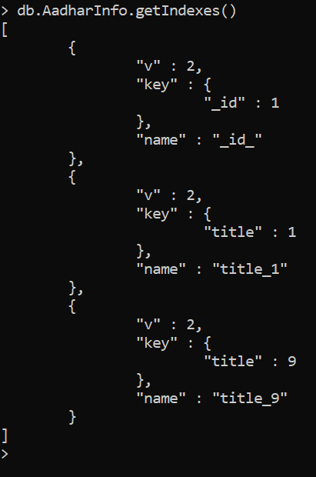

### DropIndex

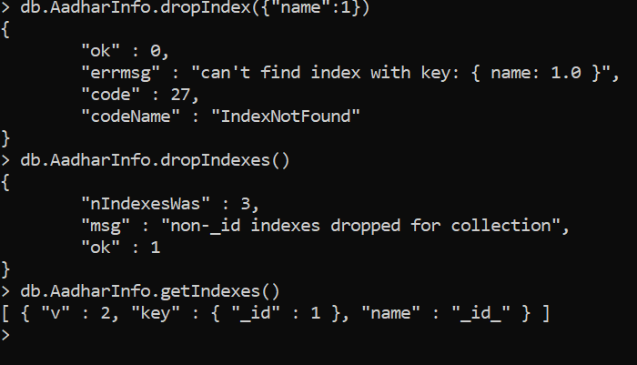

**Conclusion:**SuccessfullyexecutedMongoDBcommands.

### PRACTICAL4

**Aim:**ImplementationofHive:CreationofDatabaseandTable,HivePartition,HiveBuiltinFunctionandOperators,HiveVi ewandIndex.

### Theory:

**Introductiontohive:**

* HiveisadatawarehouseinfrastructuretooltoprocessstructureddatainHadoop. Itresides ontopofHadooptosummarizeBigData,andmakesqueryingandanalyzingeasy.
* Initially Hive was developed by Facebook, later the Apache Software Foundation took it up anddevelopeditfurtherasanopensourceunderthenameApacheHive.Itisusedbydifferentcom panies.Forexample,AmazonusesitinAmazonElasticMapReduce.
* Using Hive, we can skip the requirement of the traditional approach of writing complex MapReduceprograms.HivesupportsDataDefinitionLanguage(DDL),DataManipulationL anguage (DML),and User DefinedFunctions (UDF).

### Hiveisnot:

Arelationaldatabase. AdesignforOnlineTransactionProcessing(OLTP).Ala nguageforreal-time queriesandrow-levelupdates.

Hiveisnotcapableofhandlingreal-timedata. Itisnotdesignedforonlinetransactionprocessing.Hive queriescontainhighlatency. **o**

### FeaturesofHive:

Hiveisfastandscalable.

ItprovidesSQL-likequeries(i.e.,HQL)thatareimplicitlytransformedtoMapReduceorSparkjobs. ItiscapableofanalyzinglargedatasetsstoredinHDFS.

Itallowsdifferentstoragetypessuchasplain text,RCFile,and HBase.Itusesindexingtoacceleratequeries.

ItcanoperateoncompresseddatastoredintheHadoopecosystem. Itsupportsuser-definedfunctions(UDFs)whereusercanprovideitsfunctionality.

### ArchitectureofHive: ThefollowingcomponentdiagramdepictsthearchitectureofHive:

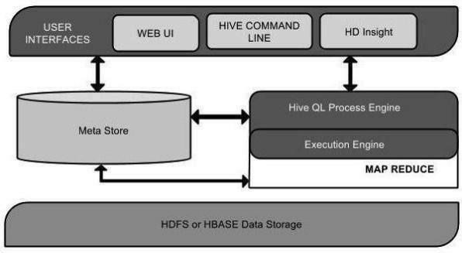

ToactivateHive,hivecommandisusedinterminal.

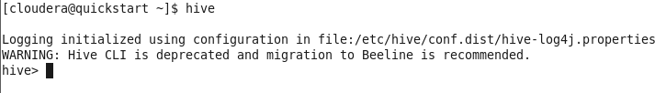

### CreationofDatabaseandTable:

**DatabaseCreationinhive–**

Hive is a database technology that can define databases and tables to analyze structured data. The theme forstructured data analysis is to store the data in a tabular manner, and pass queries to analyze it. This chapterexplainshowtocreateHivedatabase.Hivecontainsadefaultdatabasenameddefault.

Create Database Statement – Create Database is a statement used to create a database in Hive. A database inHiveisanamespaceoracollectionoftables.Thesyntaxforthisstatementisasfollows:

CREATEDATABASE|SCHEMA[IFNOTEXISTS]<databasename>

Here,IFNOTEXISTSisanoptionalclause,whichnotifiestheuserthatadatabasewiththesamenamealreadyexists. WecanuseSCHEMAinplaceofDATABASEinthiscommand.Thefollowingqueryisexecutedtocreateadataba senameduserdb:

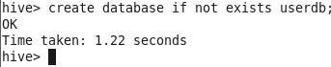

Or



### Thefollowingqueryisusedtoverifyadatabaseslist:

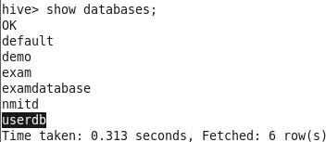

**Table Creationinhive–** CreateTableisastatementusedtocreateatableinHive.Thesyntaxandexampleareas follows:CREATE[TEMPORARY][EXTERNAL]TABLE[IFNOTEXISTS][db_name.]table_na

me [(col_namedata_type[COMMENTcol_comment],...)][ COMMENTtable_comment]

[ROWFORMAT

row_format][STOREDASfile_format]

### Example:

Let usassumeyou needtocreate atablenamedemployeeusingCREATETABLEstatement.Thefollowingtableliststhefieldsandtheird atatypesinemployeetable:

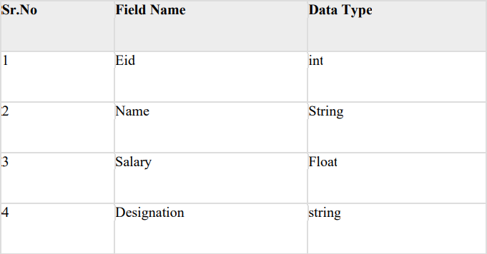

ThefollowingdataisaComment,RowformattedfieldssuchasFieldterminator,Linesterminator,andStored Filetype.

COMMENT‘Employeedetails’FIELDSTERMINATEDBY‘\t’LINESTERMINATEDBY‘\n’STORE DINTEXTFILE.

Thefollowingquerycreatesatablenamedemployeeusingtheabovedata.

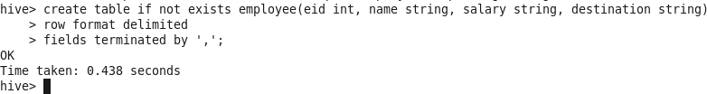

IfyouaddtheoptionIFNOTEXISTS,Hiveignoresthestatementincasethetablealreadyexists.Onsuccessful creationoftable,yougettoseethefollowingresponse:

### HivePartition:

Hiveorganizestablesintopartitions.Itisawayofdividingatableintorelatedpartsbasedonthevalues ofpartitioned columns such as date, city, and department. Using partition, it is easyto query a portion of thedata.

Tablesorpartitions aresub-divided intobuckets,toprovideextrastructuretothedatathat maybeusedformoreefficientquerying.Bucketingworksbasedonthevalueofhashfunctionofsomecolumno fatable.

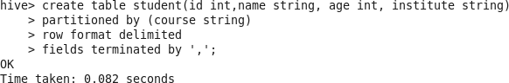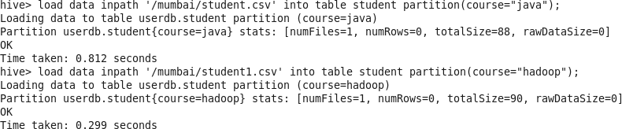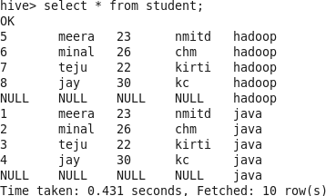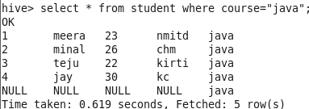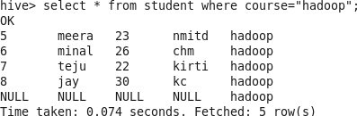

### Built-inOperators–

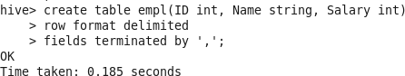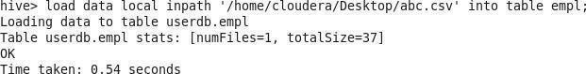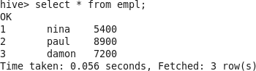

**ArithmeticOperators**

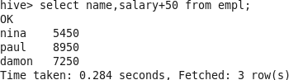

### RelationalOperators

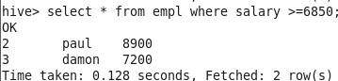

**Built-inFunctions–Sqrtfunction** **Minfunction**

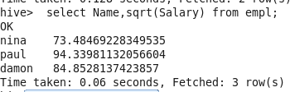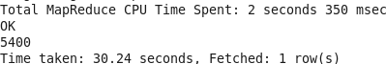

### Upperfunction

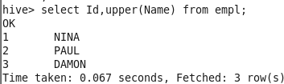

HiveQL:SelectWhere,SelectOrderBy,SelectGroupBy,SelectJoins

### OrderBy

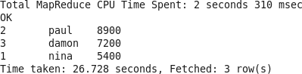

**Whereclause**

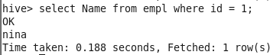

### GroupBy

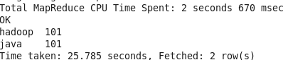

**Joins**

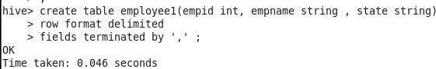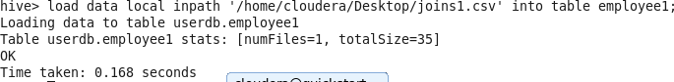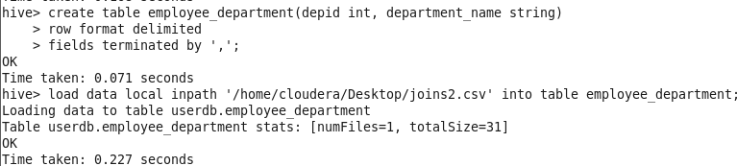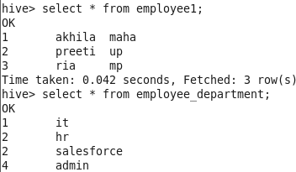

### Innerjoin

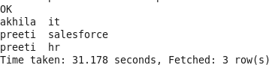

**Left outerjoin**

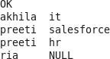

### Rightouterjoin

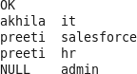

**Fullouterjoin**

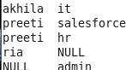

### Practical -05

**Aim: -** Pig: Pig Latin Basic, Pig Data Types, creating a Pig Data Model, Reading and Storing. Data, PigOperations

### Theory:-

ThelanguageusedtoanalyzedatainHadoopusingPigisknownasPigLatin.Itisahighleveldata processing language which provides a rich set of data types and operators to perform variousoperationsonthedata.

To perform a particular task Programmers using Pig, programmers need to write a Pig script using the PigLatin language and execute them using any of the execution mechanisms (Grunt Shell,UDFs,Embedded). After execution, these scripts will go through a series of transformations applied bythePigFramework,toproducethedesiredoutput.

Internally,ApachePigconvertsthesescriptsintoaseriesofMapReducejobs,andthus,itmakestheprogra mmer’sjob easy.

CaseSensitivity KeywordsinPigLatinarenotcase-

sensitive;forexample,LOADisequivalenttoload.Butrelationandfieldnamesare,soA=load'foo';isnotequival

enttoa=load'foo';.UDFnamesarealsocase-sensitive;thus,COUNTisnotthesameUDFascount.

ApachePigComponents

Asshowninthefigure,therearevariouscomponentsintheApachePigframework.Letustakealookatthemajorc omponents.

Parser

InitiallythePigScriptsarehandledbytheParser.Itchecksthesyntaxofthescript,doestypechecking,andothermis cellaneouschecks. Theoutputoftheparserwill be aDAG(directedacyclicgraph),whichrepresentsthePigLatinstatementsandlogicaloperators.

In theDAG,thelogicaloperatorsofthe scriptarerepresentedas thenodesandthe dataflowsarerepresentedasedges. Optimizer

Thelogicalplan(DAG)ispassedtothelogicaloptimizer,whichcarriesoutthelogicaloptimizationssuc h as projection and pushdown.

Compiler

The compiler compilestheoptimizedlogicalplanintoa seriesof MapReducejobs. Executionengine FinallytheMapReducejobsaresubmittedtoHadoopinasortedorder.Finally,these

MapReducejobsareexecutedonHadoopproducingthedesiredresults.PigLatinDa taModel

ThedatamodelofPigLatinisfullynestedanditallowscomplexnon- atomicdatatypessuchasmapandtuple.GivenbelowisthediagrammaticalrepresentationofPigLatin’sdatamodel.

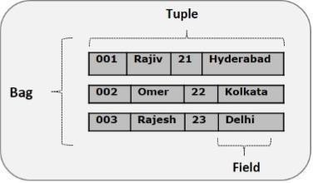

Atom

Any single value in Pig Latin, irrespective of their data, type is known as an Atom. It is stored as string and canbe used as string and number. int, long, float, double, chararray, and bytearray are the atomic values of Pig. Apieceofdataorasimpleatomicvalueisknownasafield.

Example − ‘raja’ or ‘30’Tuple

Arecordthatisformedbyanorderedsetoffieldsisknownasatuple,thefieldscanbeofanytype.Atupleissimilar toarowinatableofRDBMS.

Example −(Raja,30) Bag

Abag is an unordered setoftuples.Inotherwords,acollection oftuples(non-unique)isknownasabag. Each tuple can have any number of fields (flexible schema). A bag is represented by ‘{}’. It issimilar to a table in RDBMS, but unlike a table in RDBMS, it is not necessary that every tuple containthesamenumberoffieldsorthatthefieldsinthesameposition(column)have thesametype.

Example−{(Raja,30),(Mohammad,45)} Abagcanbeafieldinarelation;inthat context,it isknownasinnerbag.Example

-{Raja,30,{9848022338[,raja@gmail.com,](mailto:raja@gmail.com)}}Map

Amap(ordatamap)isasetofkey- valuepairs.Thekeyneedstobeoftypechararrayandshouldbeunique.Thevaluemightbeofanytype.Itisrep resentedby‘[]’

Example−[name#Raja, age#30]Relation

A relation is a bag of tuples. The relations in Pig Latin are unordered (there is no guaranteethat tuples areprocessedinanyparticularorder).

Relations,Bags,Tuples,Fields

Pig Latin statements work with relations. A relation can be defined as follows:A relationisabag(morespecifically,anouterbag).

Abagisacollectionoftuples.

Atupleisanorderedsetoffields.Afieldi s apieceof data.

APigrelationisabagoftuples.APigrelationissimilartoatableinarelationaldatabase,wherethetuplesintheb agcorrespondtotherowsinatable.Unlikearelationaltable,however,Pigrelationsdon'trequire that every tuple contain the same number of fields or that the fields in the same position (column)havethesametype.

Alsonotethatrelationsareunorderedwhichmeansthereisnoguaranteethattuplesareprocessedinanyparticul ar order. Furthermore, processing may be parallelized in which case tuples are not processedaccordingtoanytotalordering.

ReferencnigRealotins

Relationsarereferredtobyname(oralias).NamesareassignedbyyouaspartofthePigLatinstatement.Inth isexamplethename(alias)oftherelationisA.

A=LOAD'student'USINGPigStorage()AS(name:chararray,age:int,gpa:float);DUMPA;(John,18,4.0F

) (Mary,19,3.8F)

(Bill,20,3.9F)

(Joe,18,3.8F)

Youanassignanaliastoanother alias.Thenewaliascanbe usedintheplaceoftheoriginalalias torefertheoriginalrelation.

A=LOAD'student'USINGPigStorage()AS(name:chararray,age:int,gpa:float);B

=A;

DUMPB;

## ReferencnigFeilds

Fields arereferred to by positional notationorbyname(alias).

Positionalnotationisgeneratedbythesystem.Positionalnotationisindicatedwiththedollarsign($)andb eginswithzero(0);forexample,$0,$1,$2.

Namesareassignedbyyouusingschemas(or,inthecaseoftheGROUPoperatorandsomefunctio ns,bythesystem).YoucanuseanynamethatisnotaPigkeyword(seeIdentifiersforvalidnameexample s).

Given relation A above, the three fields are separated out in this table. Pig Latinhasthesefourtypesinitsdatamodel:

Atom:Anatomisanysinglevalue,suchasastringoranumber—‘Diego’,forexample.Pig’s atomic values are scalar types that appear in most programming languages — int, long,float,double,chararrayandbytearray,forexample.

Tuple: A tupleis a record that consists of a sequence of fields. Each field can be of any type — ‘Diego’,‘Gomez’,or6,forexample).Thinkofatupleasarowinatable.

Bag:Abagisacollectionofnon-uniquetuples.Theschemaofthebagisflexible— eachtupleinthecollectioncancontainanarbitrarynumberoffields,andeachfieldcanbeofanytype.

Map:Amapisacollectionofkeyvaluepairs.Anytypecanbestoredinthevalue,andthekeyneedstob eunique.Thekeyofamapmustbeachararrayandthevaluecanbeofanytype.

Commands:

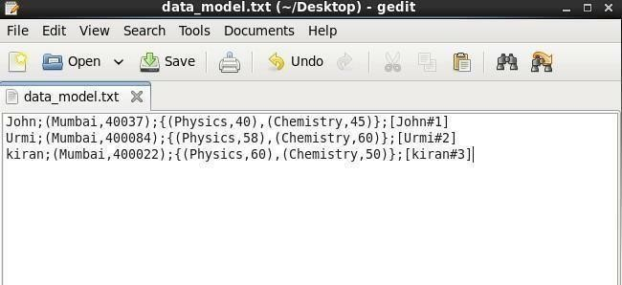

Pig-xlocal

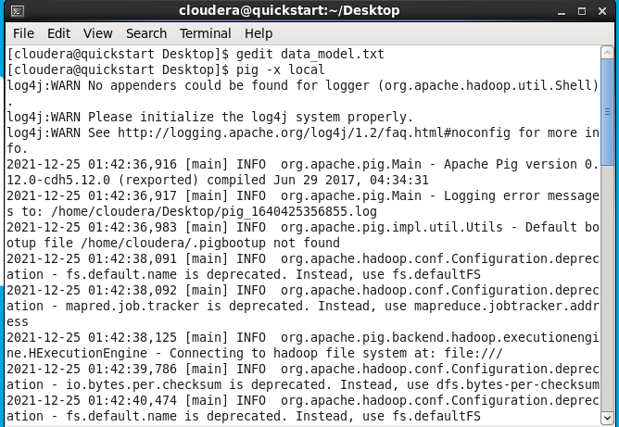

DataModels=LOAD ‘data_model’ using PigStorage(‘;’) AS

(name:chararray,address:tuple(city:chararray,pincode:chararray),result:bag{info:tuple(s ub:chararray,marks:int)},m:map[int]);

dumpDataModels;

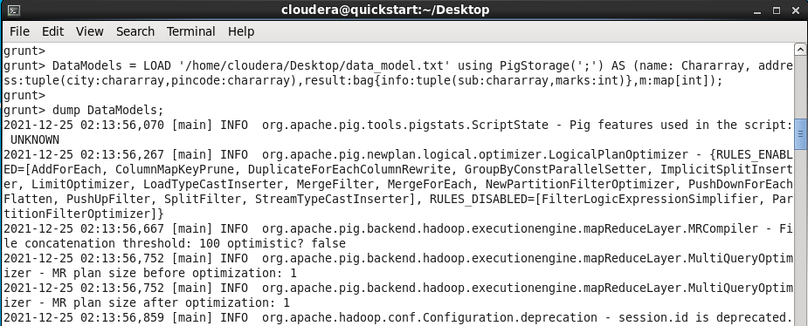

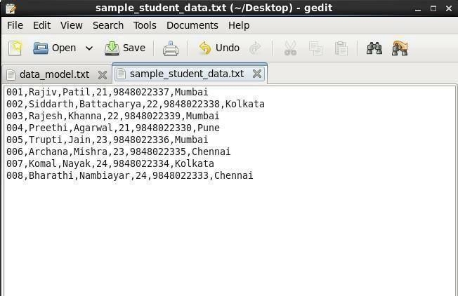

student_info=LOAD'/home/cloudeía/Desktop/sample_student_data.txt'usingPigStoíage(',')AS(id:chaíaííay,fna me:chaíaííay,lname:chaíaííay,age:int,phone:chaíaííay,city:chaíaííay);

dumpstudent_info

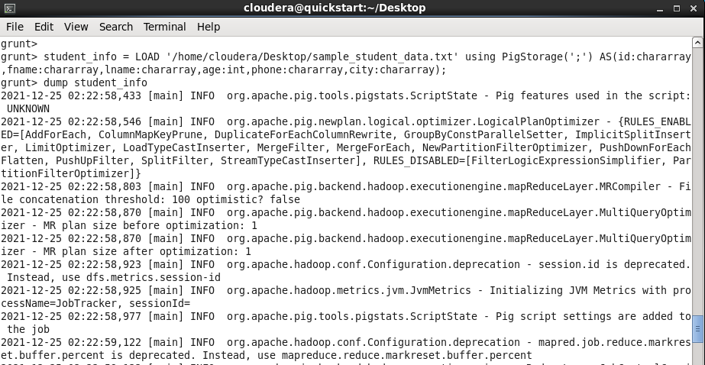

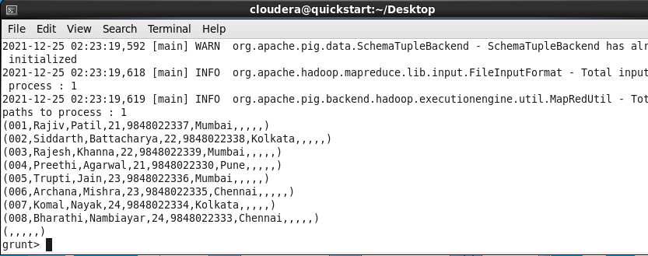

StoreData:

Storestudent_infointo'sampleoutput' usingPigStorage('|');

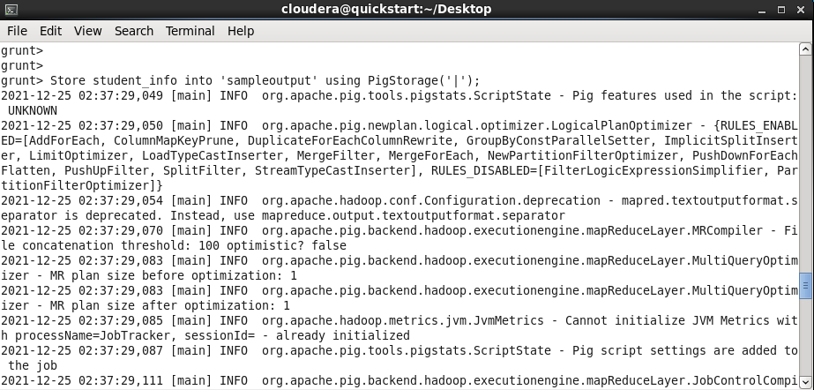

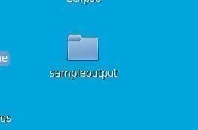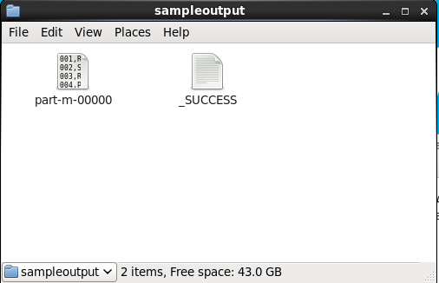

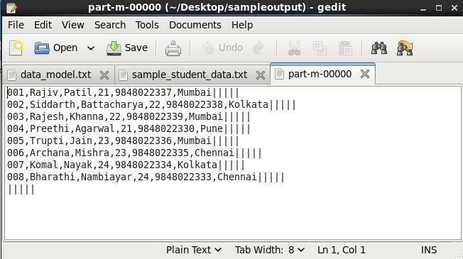

PigOperations:

Operators

describestudent_info

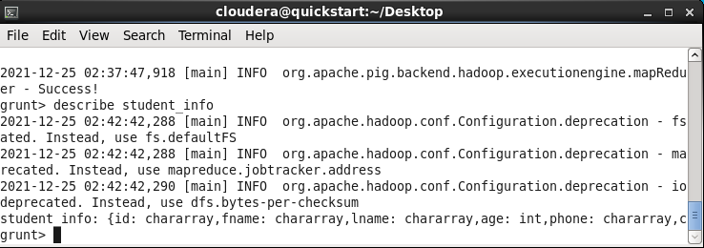

FilterData:

# filterstudent=filterstudent_infoBYage>22;dumpfilterst udent;

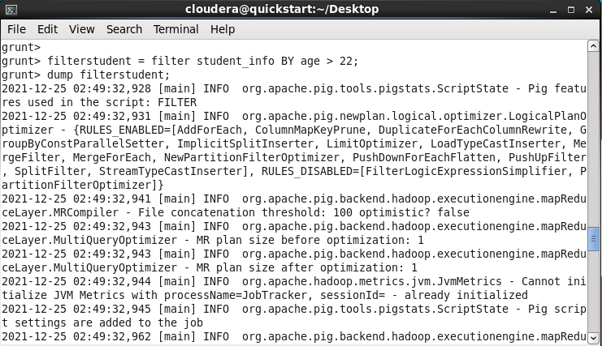

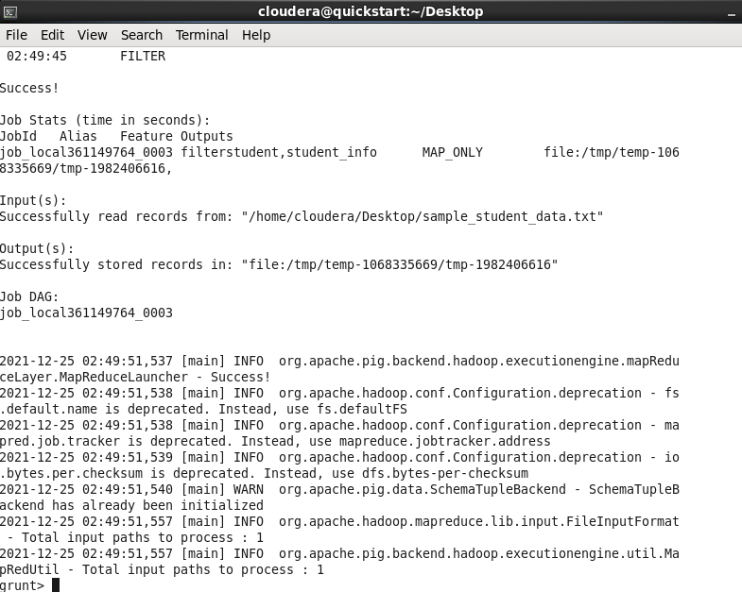

EXPLAINfilterstudent

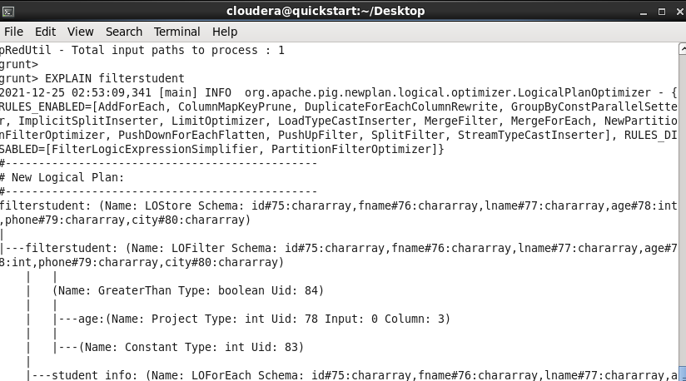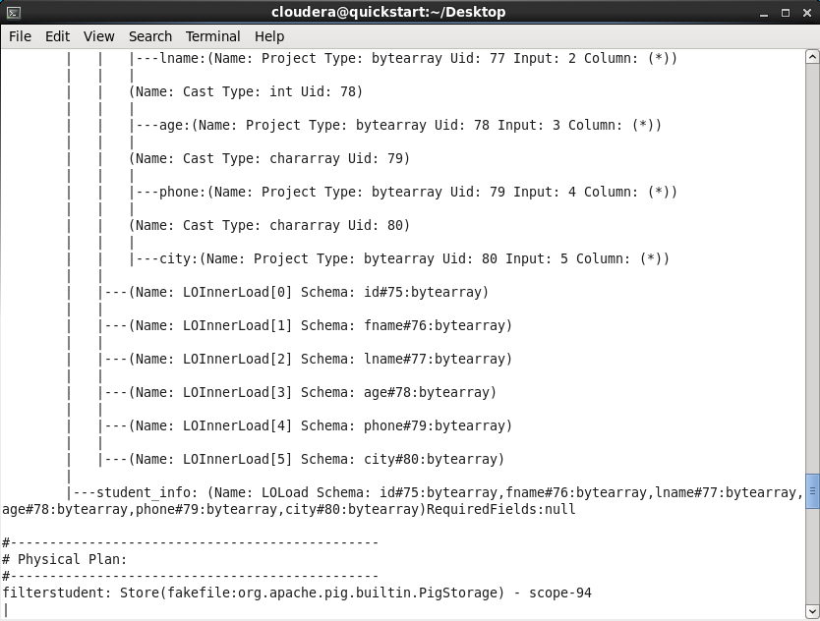

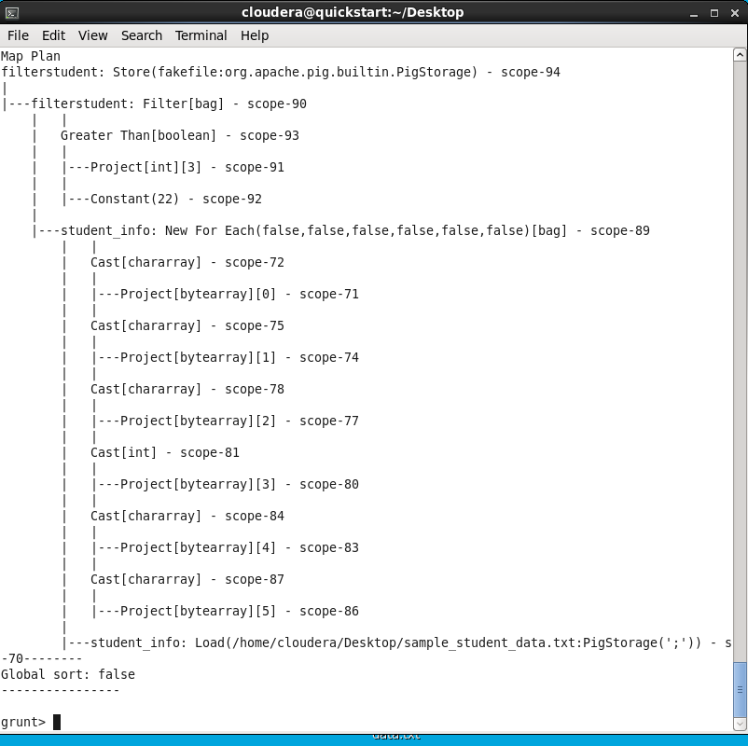

foíeachstudent = foíeach filteístudent geneíate id, fname, age, city;dumpfoíeachstudent

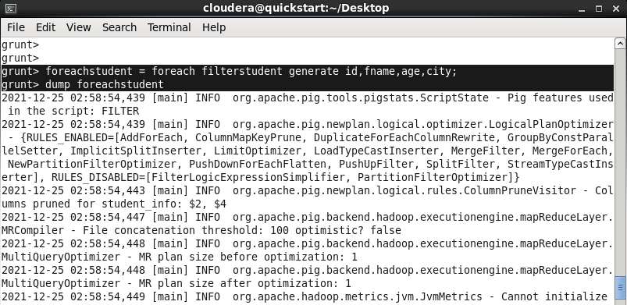

GROUP:

gíoupstudent=GROUPstudent_infobycity;dumpgíoupstudent

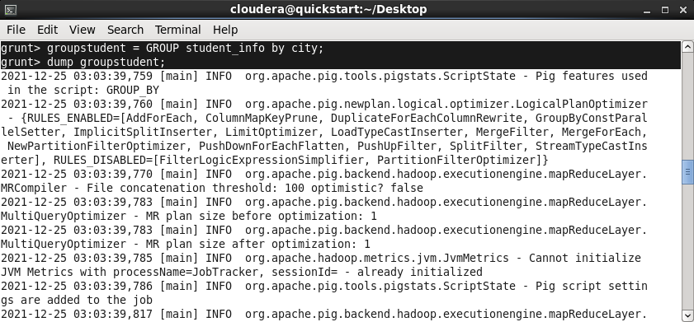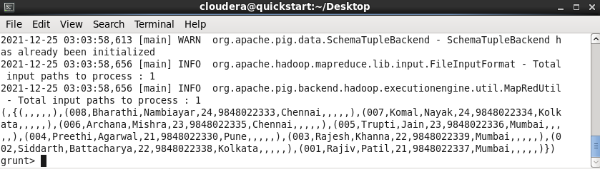

ILLUSTRATE:

# Illustrateforeachstudent;

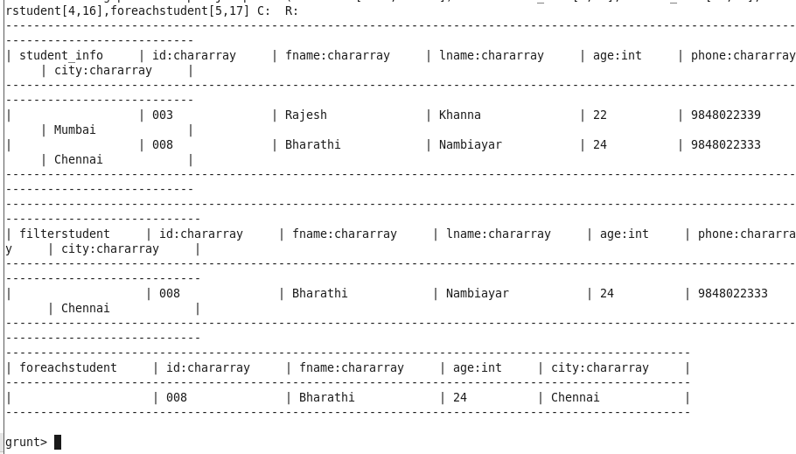

describegroupstudent

groupstudent:{group:chararray,student_info:{(id:chararray,fname:chararray,lname:chararray,age:int,phone:chararray,city:ch ararray)}}

groupstudent2=groupstudent_infoby(city,age);dumpgroupstudent2;

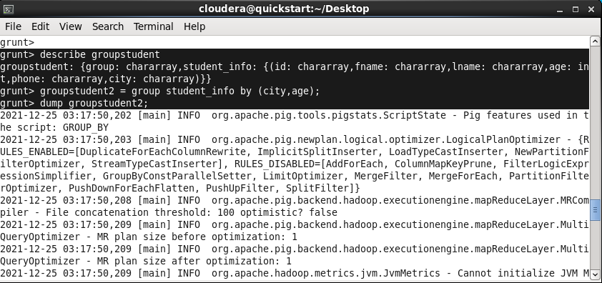

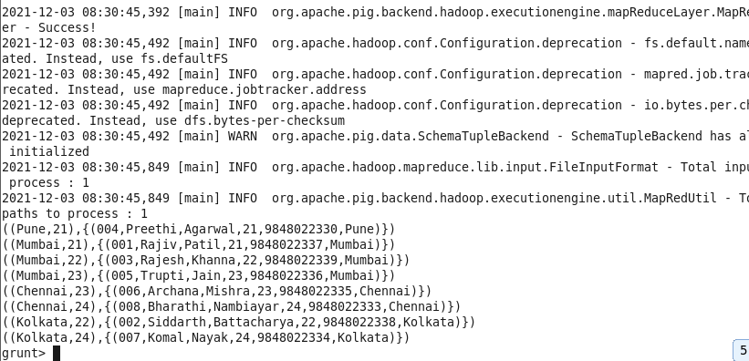

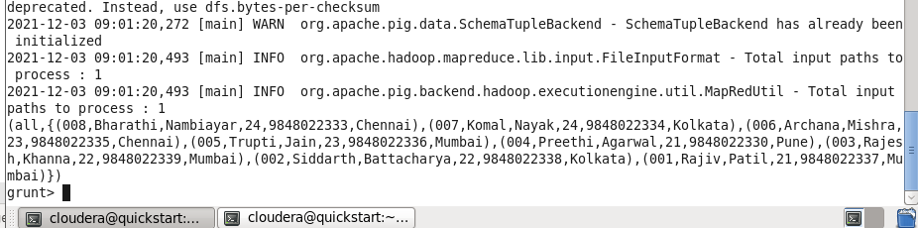groupstudent3=groupstudent_infoall;dumpgr oupstudent3;

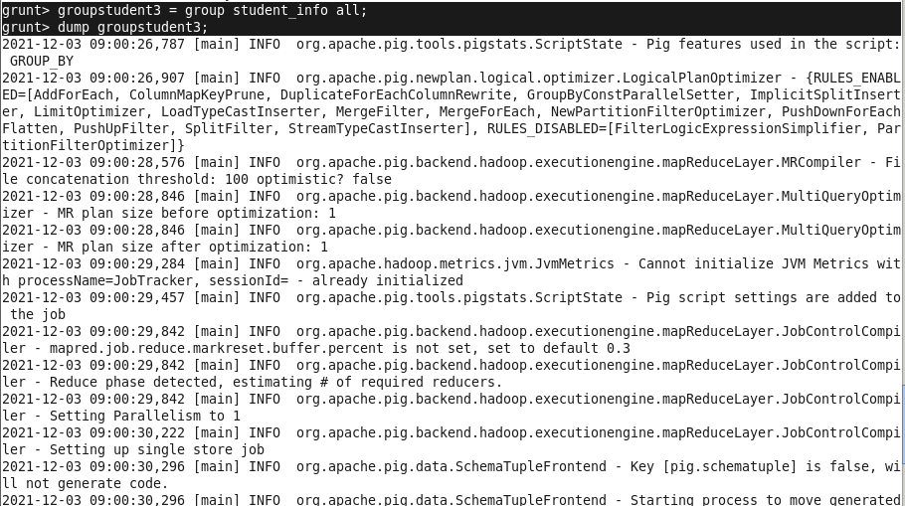

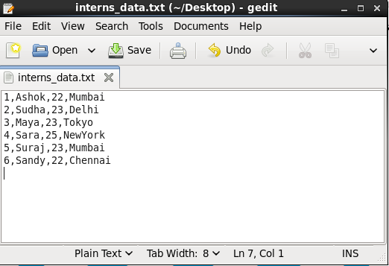

I = LOAD '/home/cloudera/Desktop/interns_data.txt' using PigStorage(',')AS(id:chararray,fname:chararray,age:int,city:chararray);

dumpI;

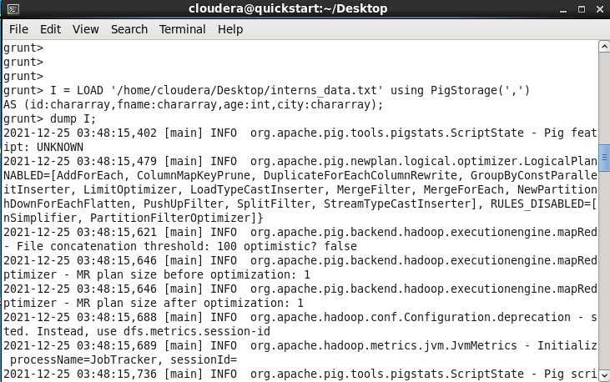

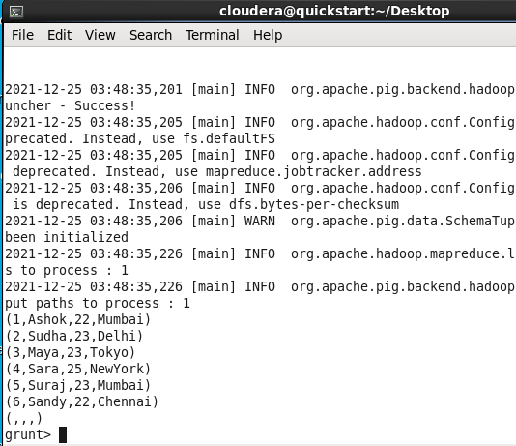

COGROUP:

CG=COGROUPstudent_infobyage,Ibyage;grunt>dumpCG;

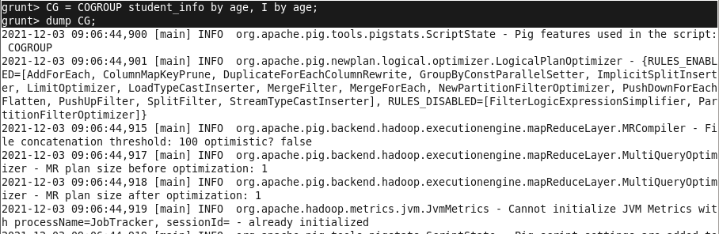

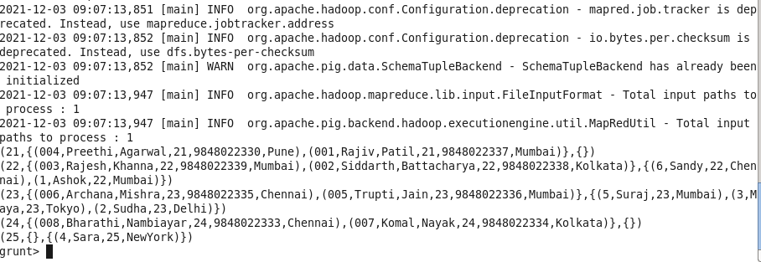

student_infoB = LOAD '/home/cloudera/Desktop/sample_student_data.txt' usingPigStorage(',')

AS

(id:chararray,fname:chararray,lname:chararray,age:int,phone:chararray,city:chararray); SelfJoin

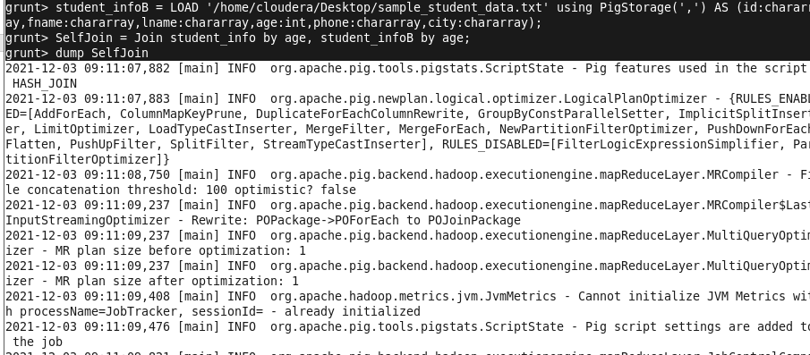=Joinstudent_infobyage,student_infoBbyage;dump SelfJoin

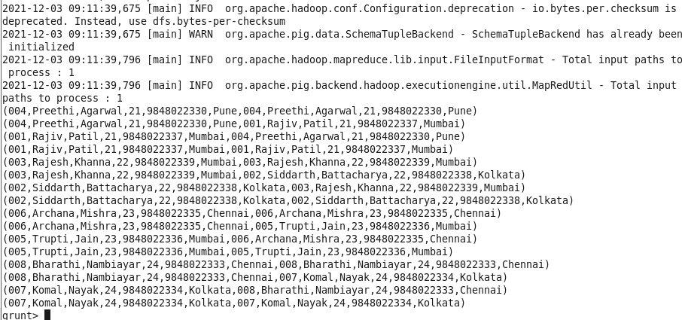

Joins:

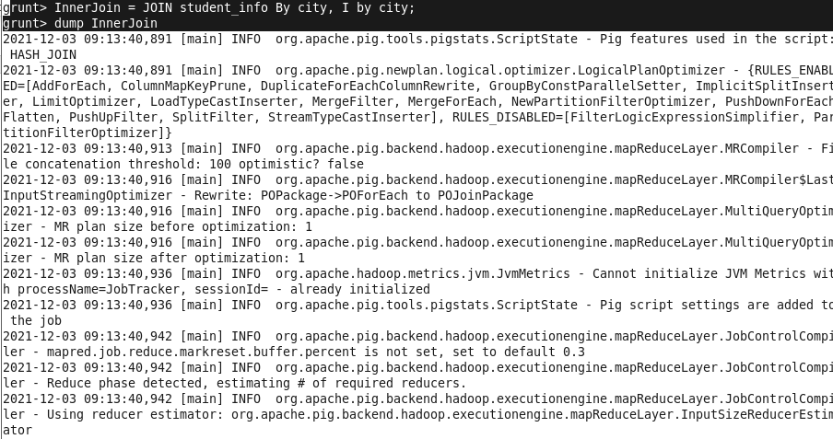InnerJoin: InnerJoin=JOINstudent_infoBycity,Ibycity;dumpInne rJoin

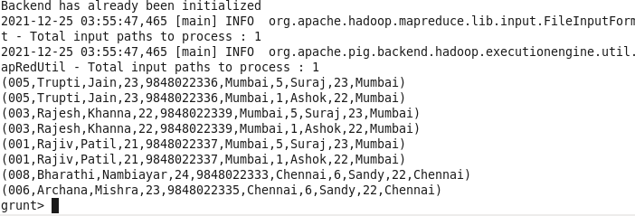

LeftJoin:

LeftJoin=JOINstudent_infoBycityLEFT,Ibycity;grunt>dumpLeftJoin

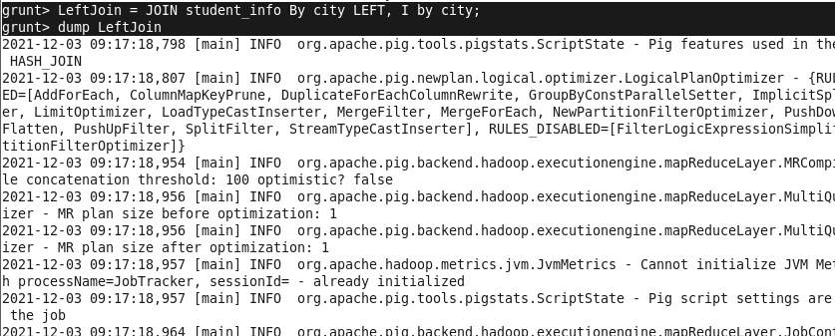

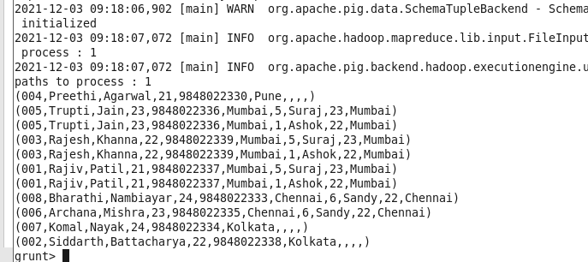

RightJoin:

RightJoin=JOINstudent_infoBycityRIGHTOUTER,Ibycity;grunt>dumpRightJoin;

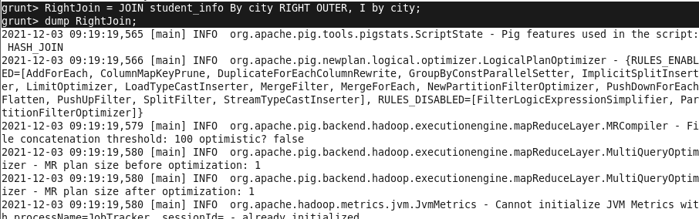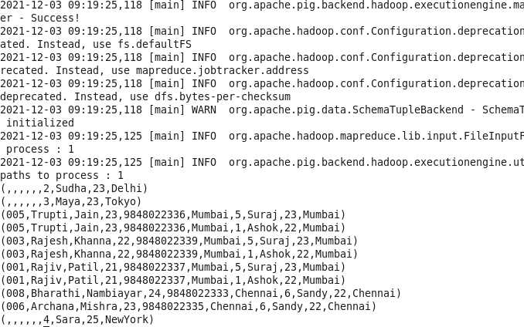

FullJoin:

FullJoin=JOINstudent_infoBycityFULLOUTER,Ibycity;dumpFullJoi n

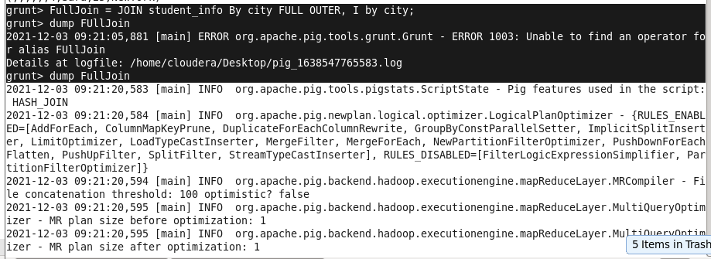

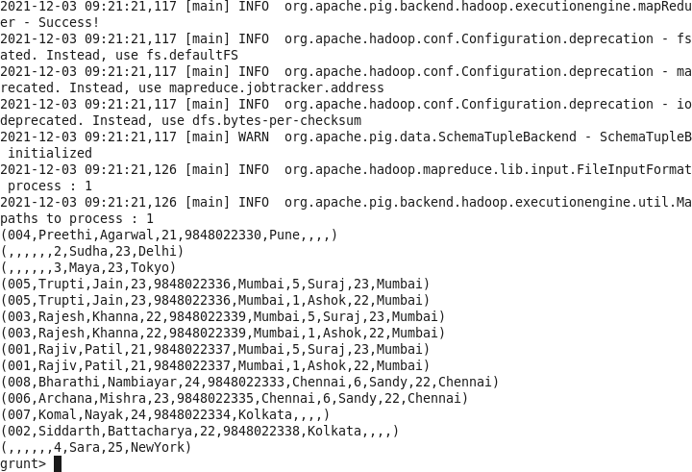

SPLITING:

splitstudent_infointoyounger_studentsifage<23,older_studentsifage>=23;dumpstudent_inf o

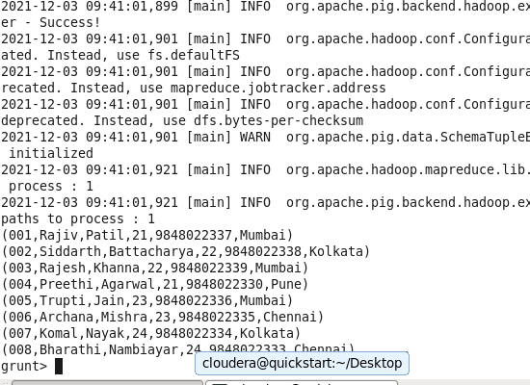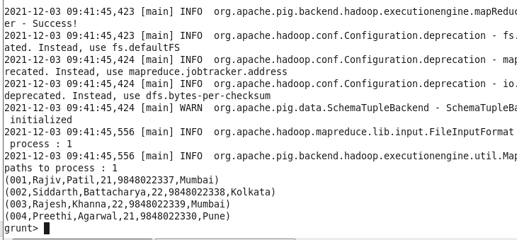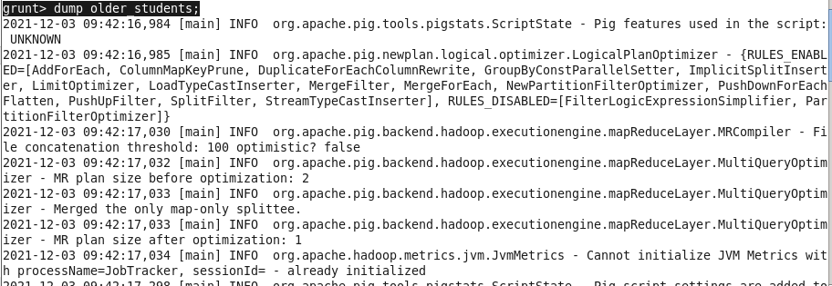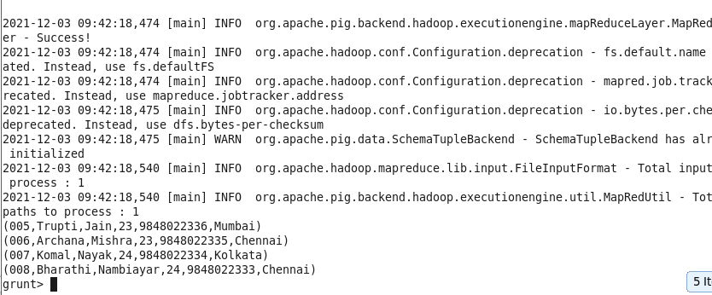

FILTERING:

filter_city=FILTERstudent_infobycity=='Mumbai';dumpfilter_c ity



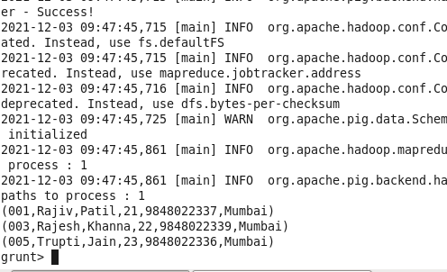



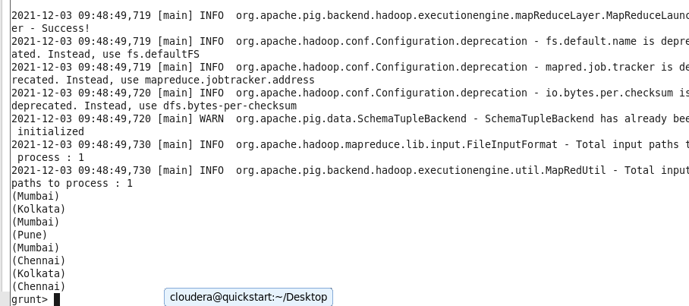

distinct_cities=Distinctall_city;dumpdistinct_c ities;

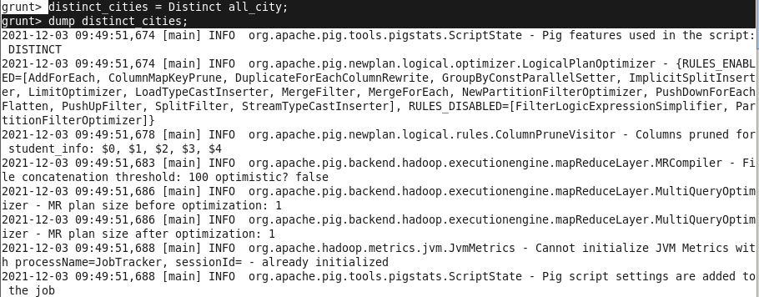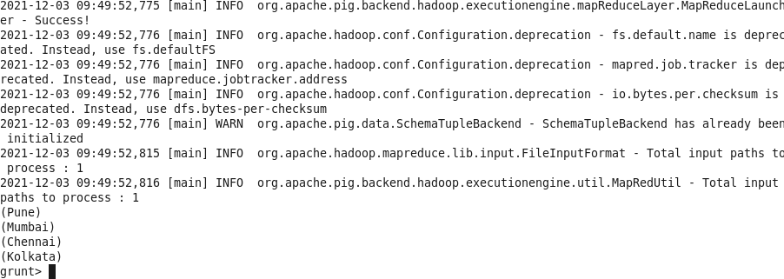

**Practical-6**Spark **Aim:**Torunsparkcommandsandfunctions

### Theory:

Apache Spark is an open-source unified analytics engine for large-scale data processing. Spark provides aninterface for programming entire clusters with implicit data parallelism and fault tolerance. Originallydeveloped at the University of California, Berkeley's AMPLab, the Spark codebase was later donated to theApache Software Foundation, which has maintained it since. Below snapshots demonstrates various sparkshellcommandsandtheiruses.

Commands and Steps: Open cloudera’s desktop terminal OpenclouderaVM->terminal ;type spark-shellandenter

* + spark-shell

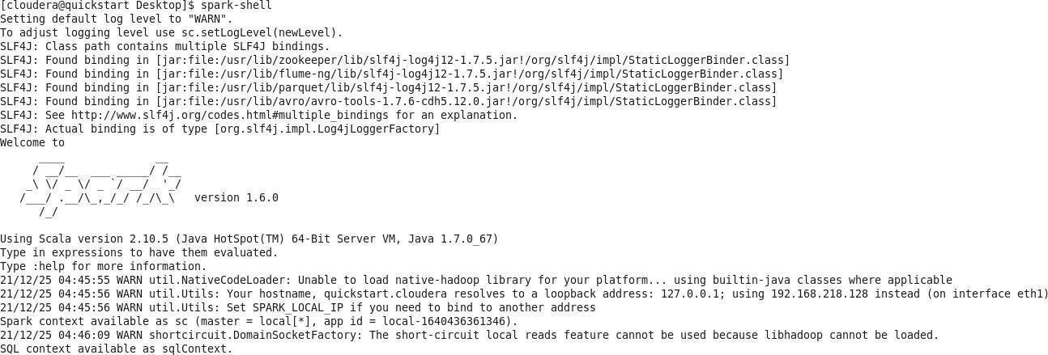

* + data.collect

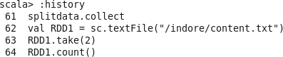

valmapfunc=data.map(x=>x+10)



mapfunc.collect



valdata=sc.parallelize(List(20,60,40,100))



#### data.collect



valfilterfunc=data.filter(x=>x!=40)



filterfunc.collect



valcountfunc=data.count()



data.collect



valdistinctfunc=data.distinct()



valdistinctfunc=data.count()



distinctfunc.collect



valdata1=sc.parallelize(List(20,60,40,100,20))



valdistinctfunc=data1.distinct()



scala>distinctfunc.collect



### val data2=sc.parallelize(List(1,

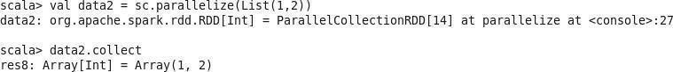

***data2.collect***

**2))**

val data3

=sc.parallelize(List

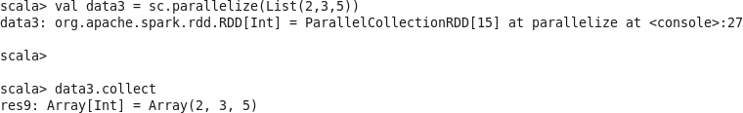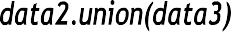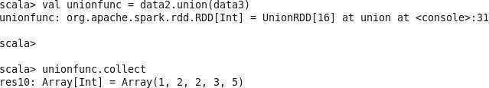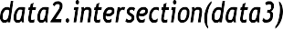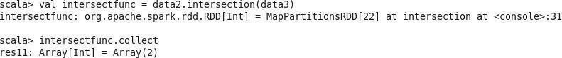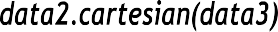

(2,3,5))

data3.collect

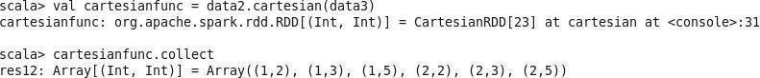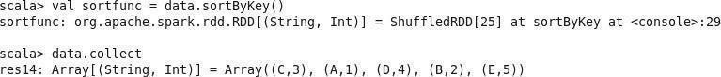



sortfunc.collect

val sortfunc

=data.sortByKey(fal se)sortfunc.collect

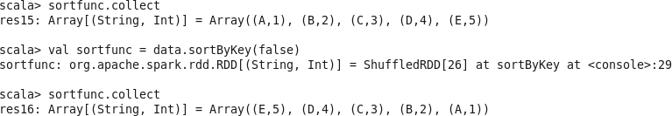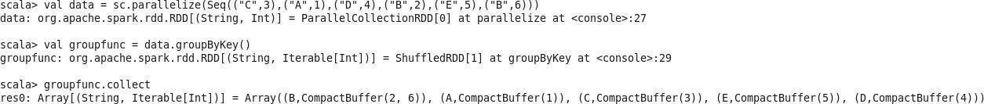

***reducefunc.collect***

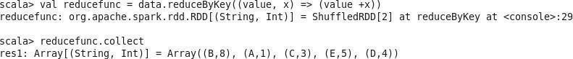

cogroupfunc.collect

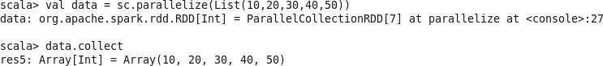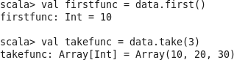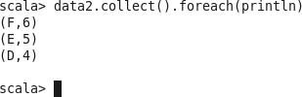

val data

=sc.textFile("/indore/cont

ent.txt")data.collect



valsplitdata=data.flatMap(line=>line.split(""));splitdata.collect



* val RDD1=sc.textFile("/indore/content.txt")
* RDD1.take(2)



* RDD1.count()



* valsplitdata= RDD1.flatMap(line=>line.split(""));
* splitdata.collect
* for(line<-RDD1.take(2))println(line)
* valmapdata=splitdata.map(word=>(word,1));
* mapdata.collect()

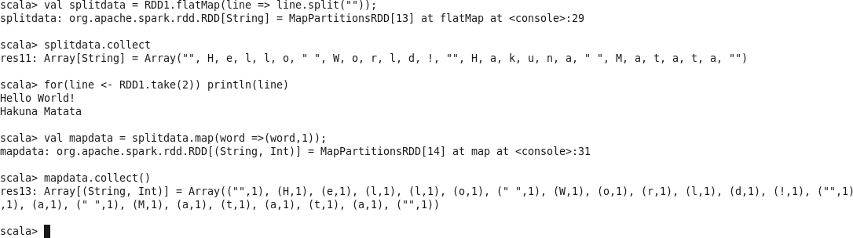

* valreducedata=mapdata.reduceByKey(_+_);
* reducedata.collect()
* valmapdata=RDD1.map(word=>(word,1));
* mapdata.collect
* valsplitdata=RDD1.flatMap(line=>line.split(""));
* splitdata.collect

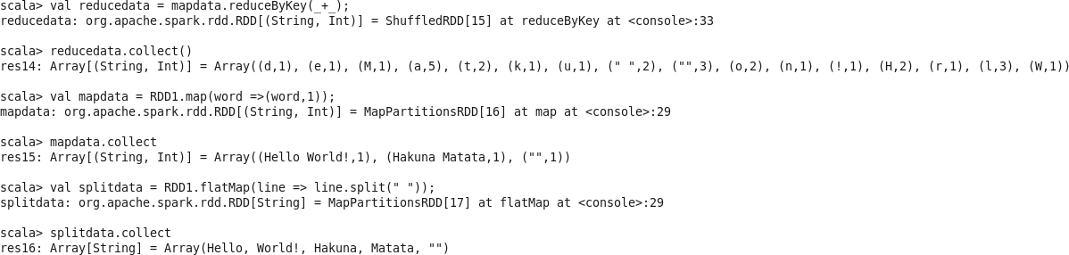

**Practical7**

**Aim:-**

# Visualization:Connecttodata,BuildChartsandAnalyzeData,CreateDashboard,CreateStories usingTableau.

**Theory:-**

Tableau Software is an American interactive data visualization software company focused on businessintelligence. It was founded in 2003 in Mountain View, California, and is currently headquartered inSeattle,Washington.In2019thecompanywasacquiredbySalesforcefor

$15.7 billion. At the time, this was the largest acquisition by Salesforce (a leader in the CRMfield) since itsfoundation.

ItwaslatersurpassedbySalesforce'sacquisitionofSlack.Tableauproductsqueryrelational databases,online analytical processing cubes, cloud databases, and spreadsheets to generate graph-type datavisualizations. The software can also extract, store, and retrieve data from an in- memorydata engine. Tableauhas a mapping functionality and can plot latitude and longitude coordinates and connect to spatial files likeEsriShapefiles,KML,andGeoJSONtodisplaycustomgeography.

The built-in geocoding allows for administrative places (country, state/province, county/district),postal codes, US Congressional Districts, US CBSA/MSA, Area Codes, Airports, and European Unionstatistical areas (NUTS codes) to be mapped automatically. Geographies can be grouped to create customterritoriesorcustomgeocodingusedtoextendexistinggeographicrolesintheproduct.

AnalysisOperations Q1:Findthecustomerwiththehighestoverallprofit.Whatishis/herprofitratio?Ans:Step1:Openthesupersto reus2015excel dataset

Step2:DragOrderssheettosheetarea Step3:Gotosheet1andaddCustomernameasrowsandprofitascolumn

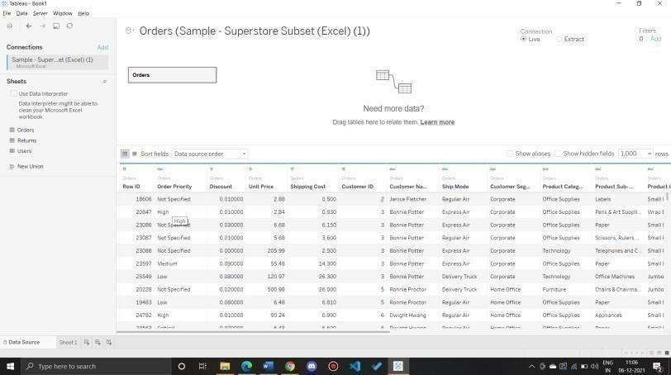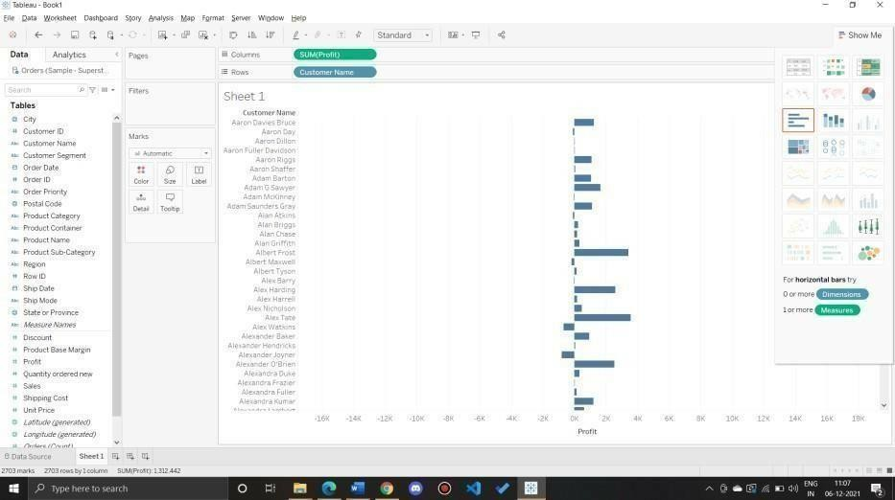

Step4:Sortthedatabyclicking onProfitlabel on bottom

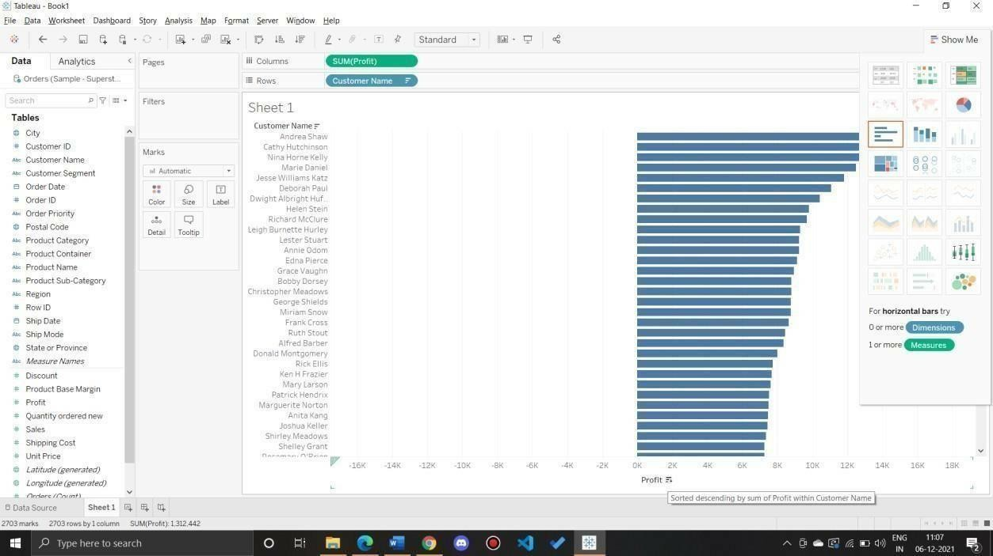

Step5:TocalculateprofitRatio

Profit Ratio=(Sum([Profit])/Sum([Sales])) Thisformulaneedsto beenteredastooltiporlabel ClickonAnalysis>Create CalculatedFieldand entertheformula

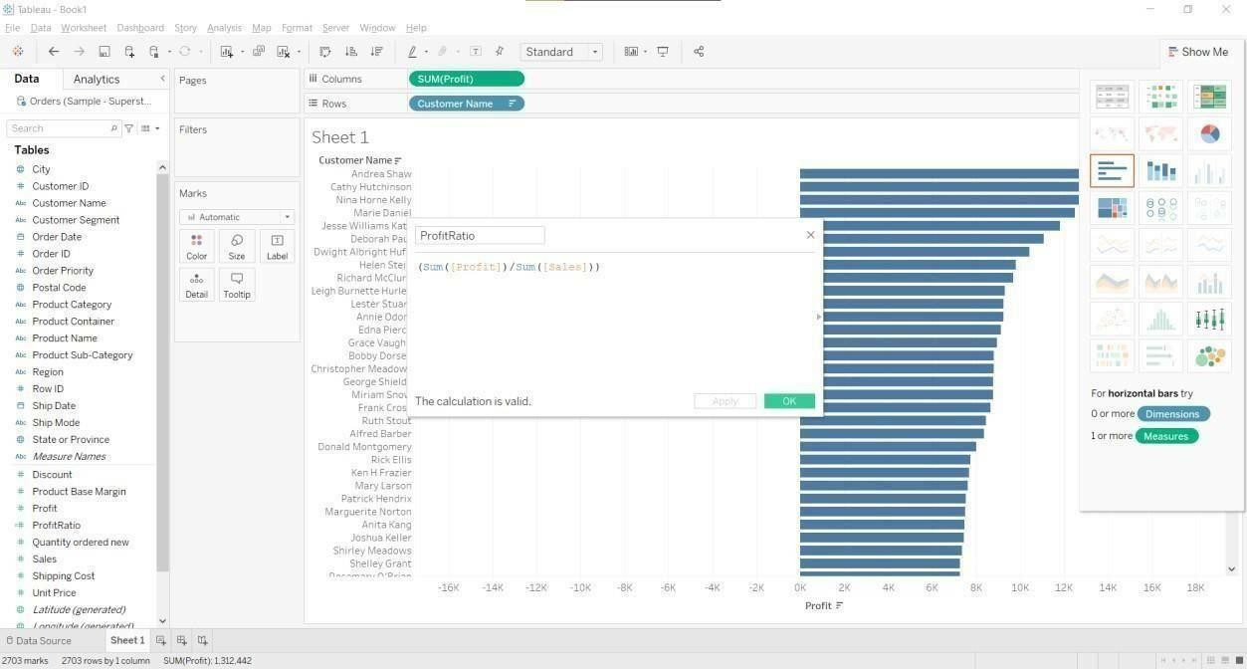

YoucanseeProfitRatio(Ornameyouprovided)inmeasures.DragistoMarksarea.

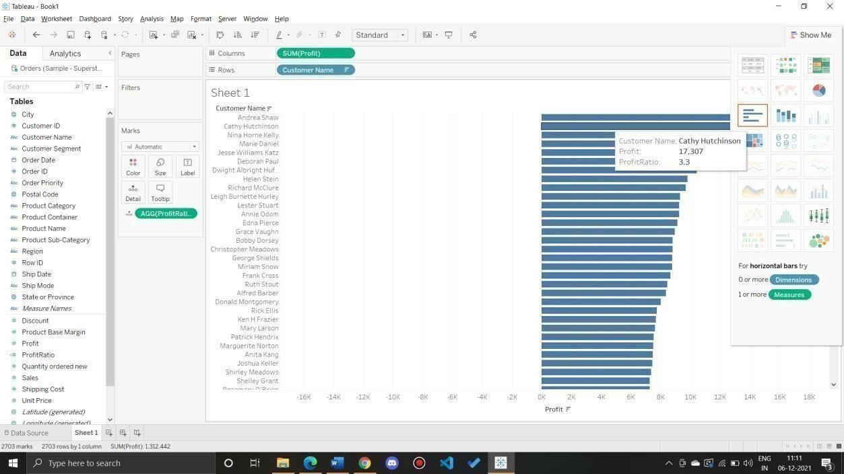

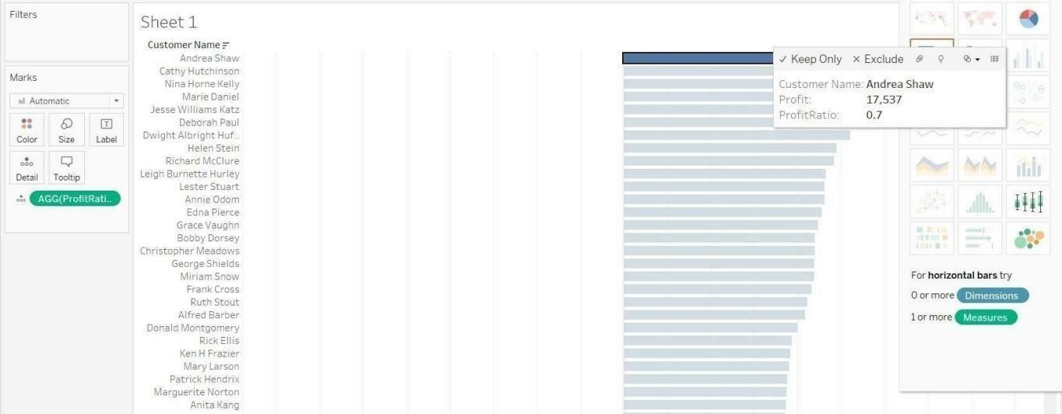

Toremovesomethingfromcolumnandrow

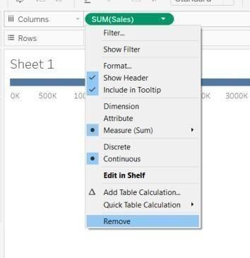

Q2:WhichstatehasthehighestSales(Sum)?WhatisthetotalSalesforthatstate?Ans:

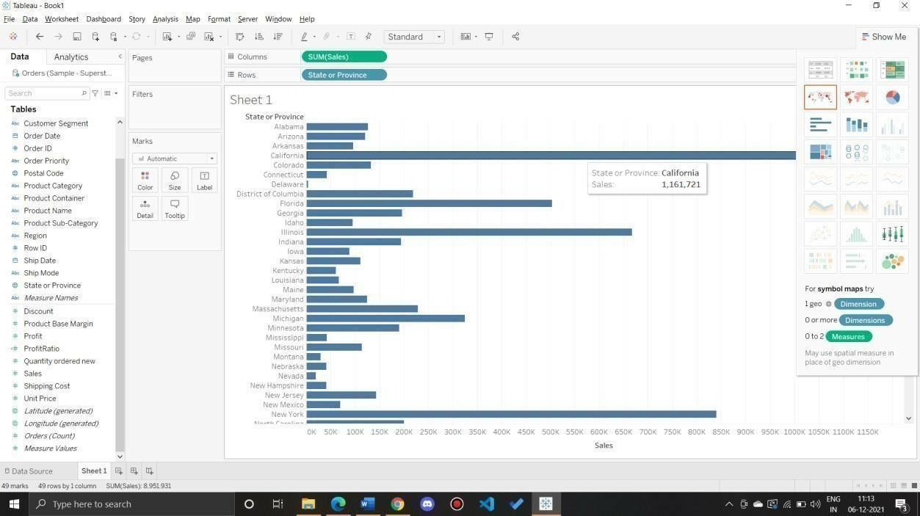

Q3:Whichcustomersegmenthasboththehighestorderquantityandaveragediscountrate?Whatistheorderquantityandaver agediscountrateforthatstate?

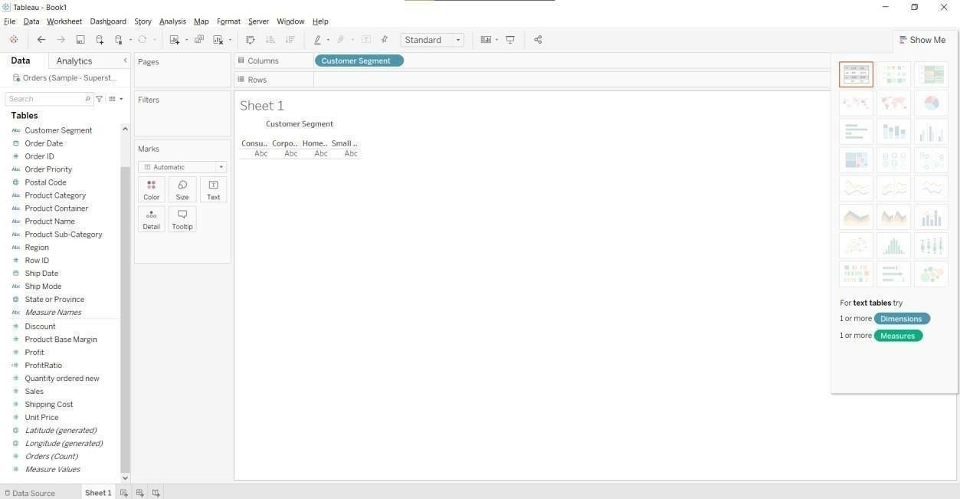

Draganddropmeasuresname.

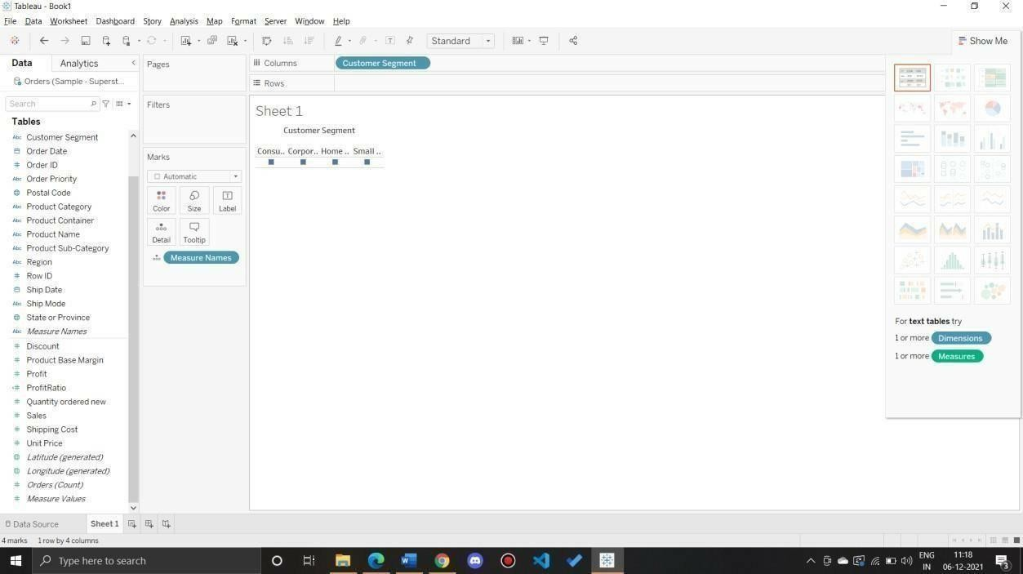

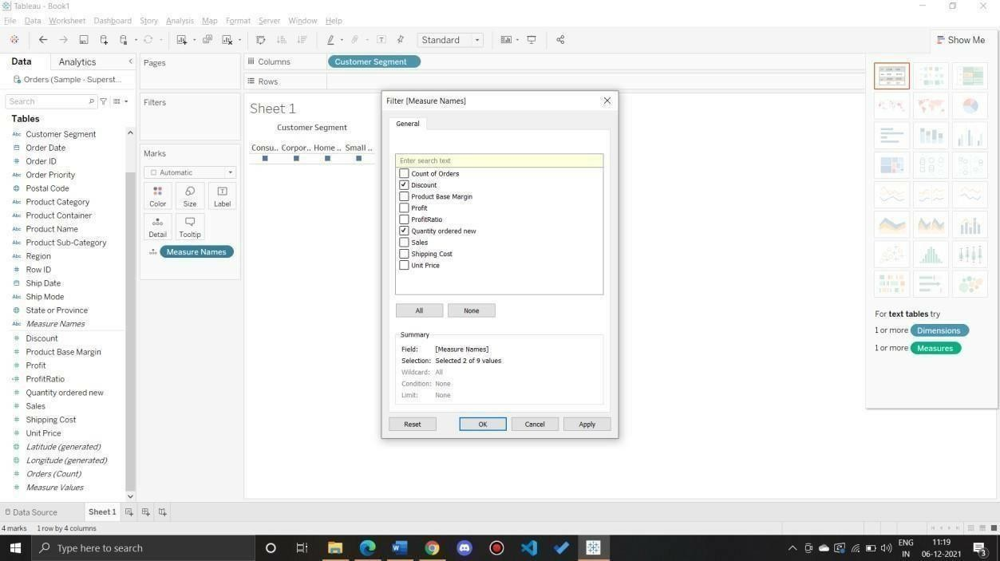

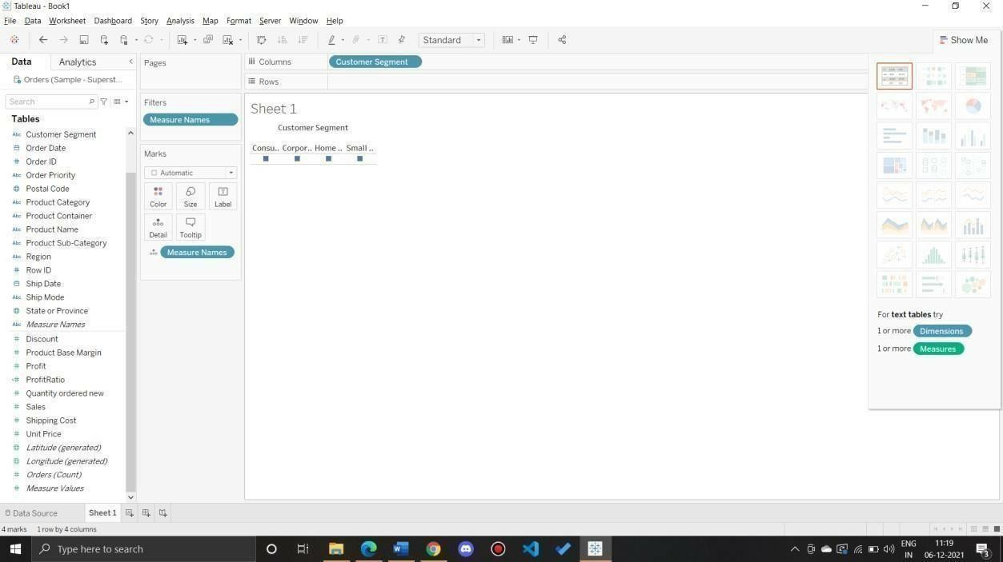

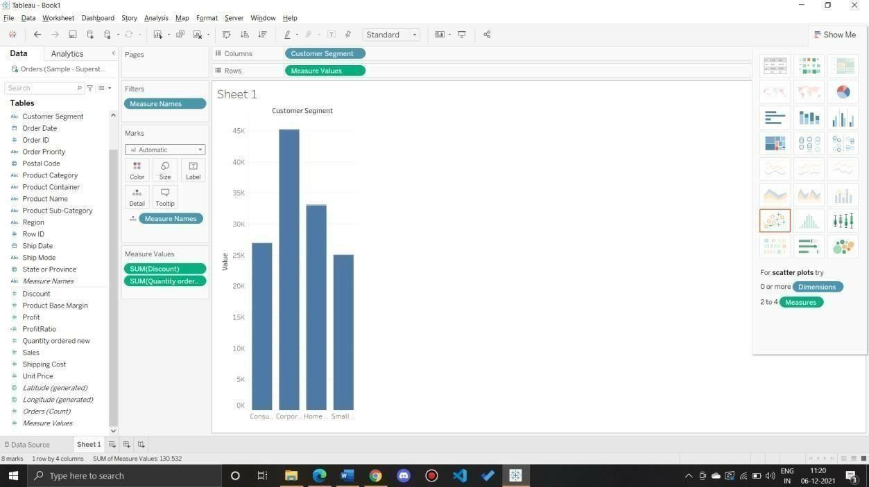

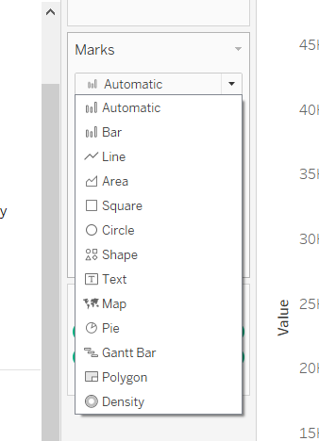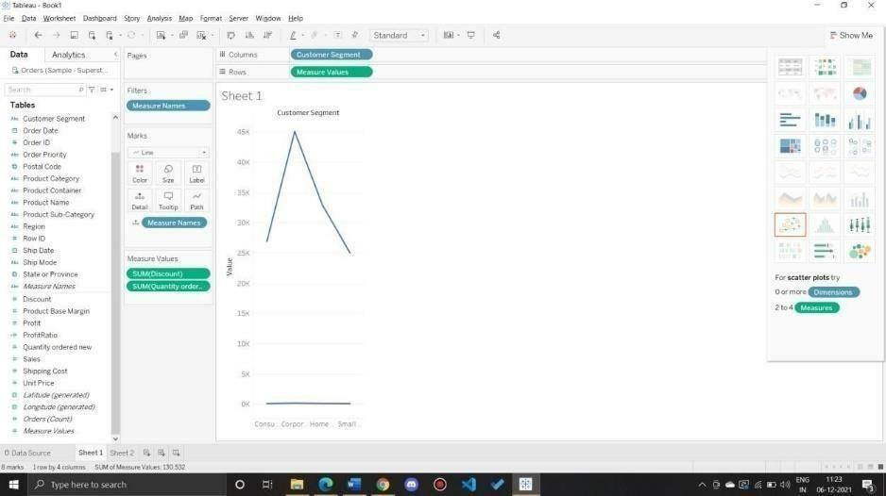

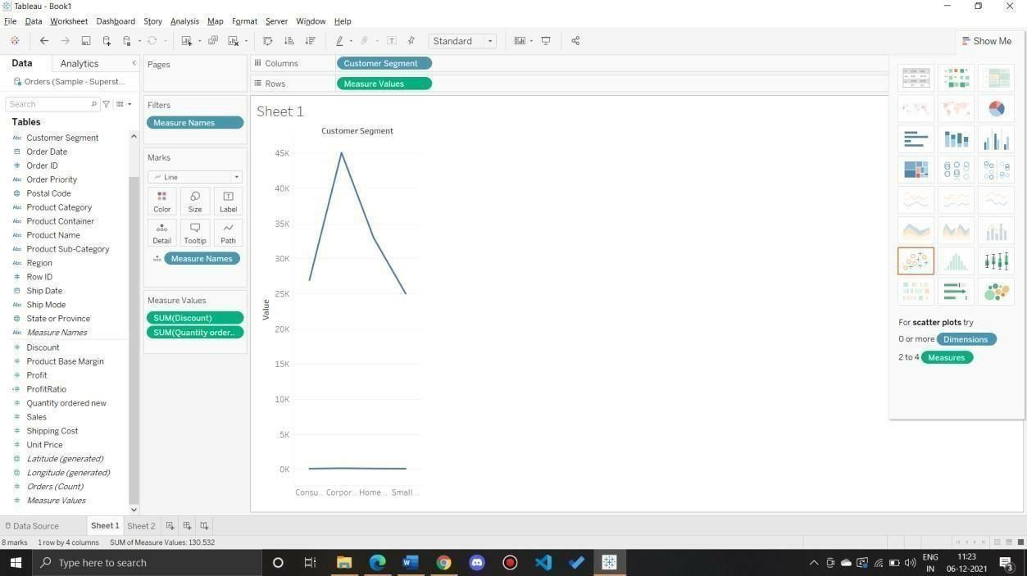

Q4:WhichProductCategoryhasthehighesttotalSales?WhichProductCategoryhastheworstProfit?NamethePro ductCategoryand$amountforeach.

Ans:

1. BarChartdisplayingtotal SalesforeachProductCategory

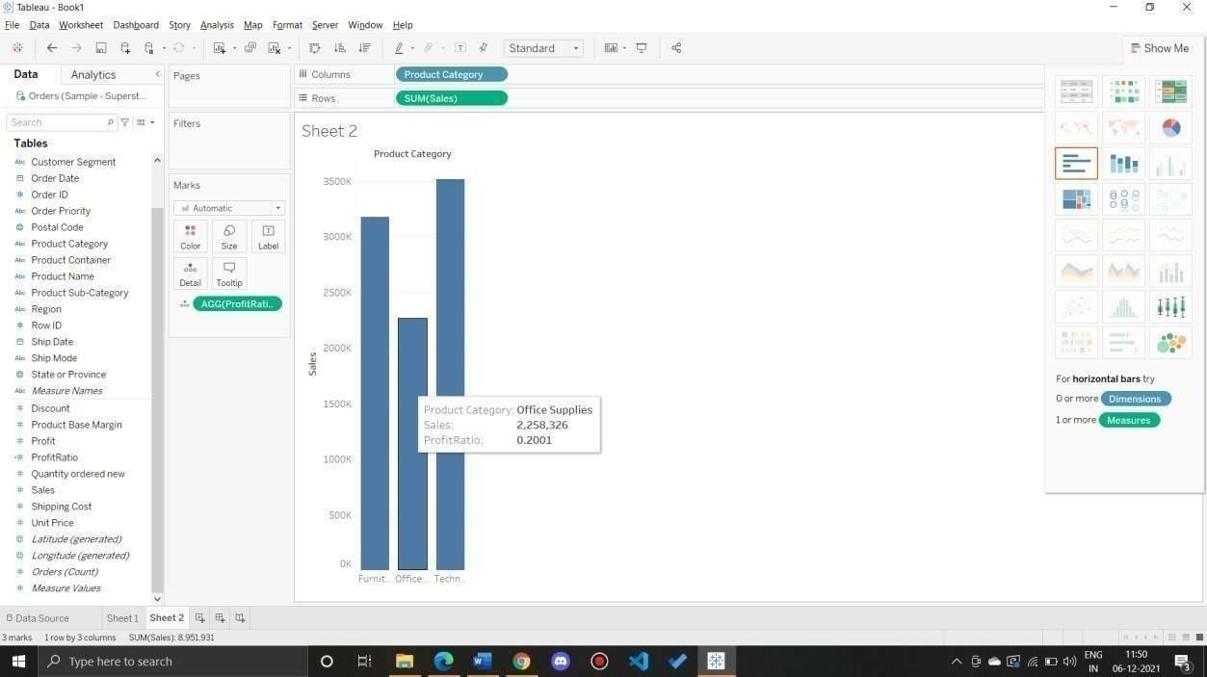

1. AddacolorscaleindicatingProfit

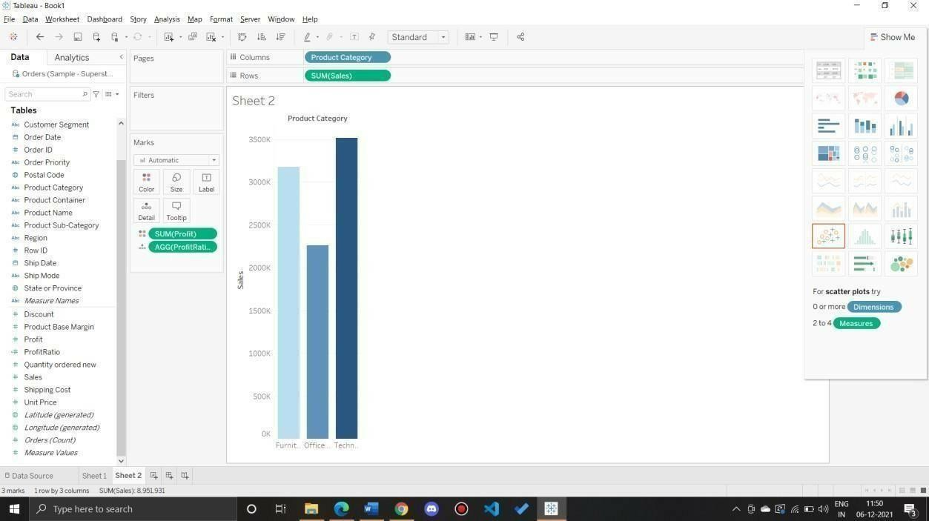

1. EachProductCategorylabeledwithtotalSalesandEachProductCategorylabeledwithProfit

Q5:UsethesamevisualizationcreatedforQuestion#4.WhatwastheProfitonTechnology(Product Category) inBocaRaton (City) ?

AddFilterCity

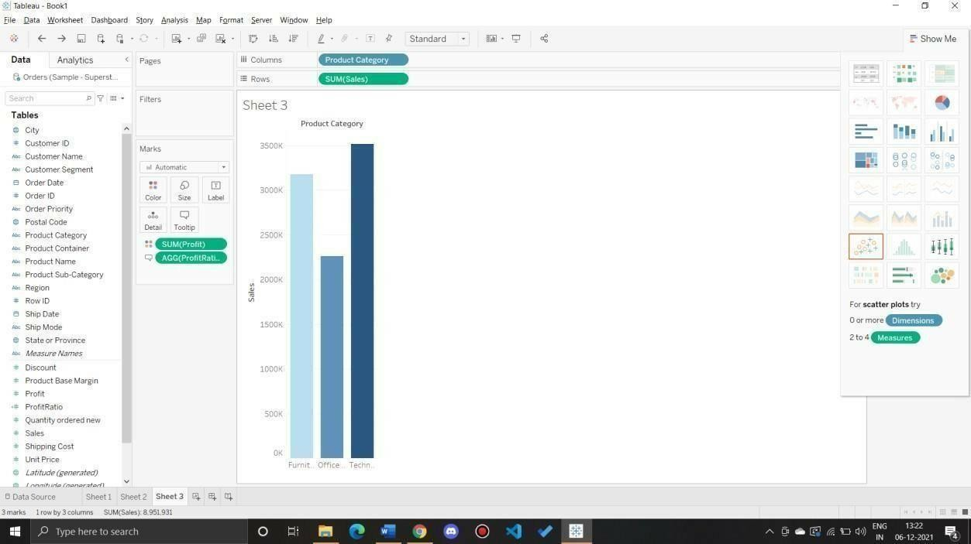

Select thecity toshowasinglebar forthecity

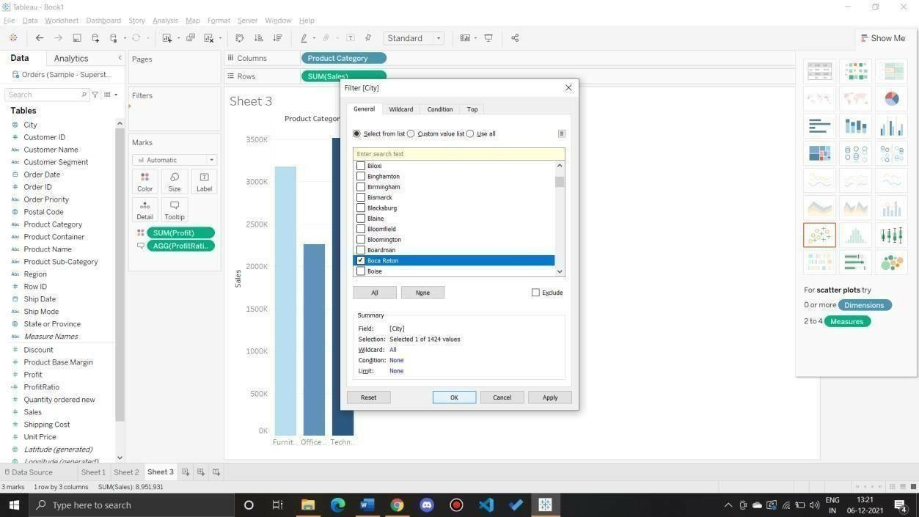

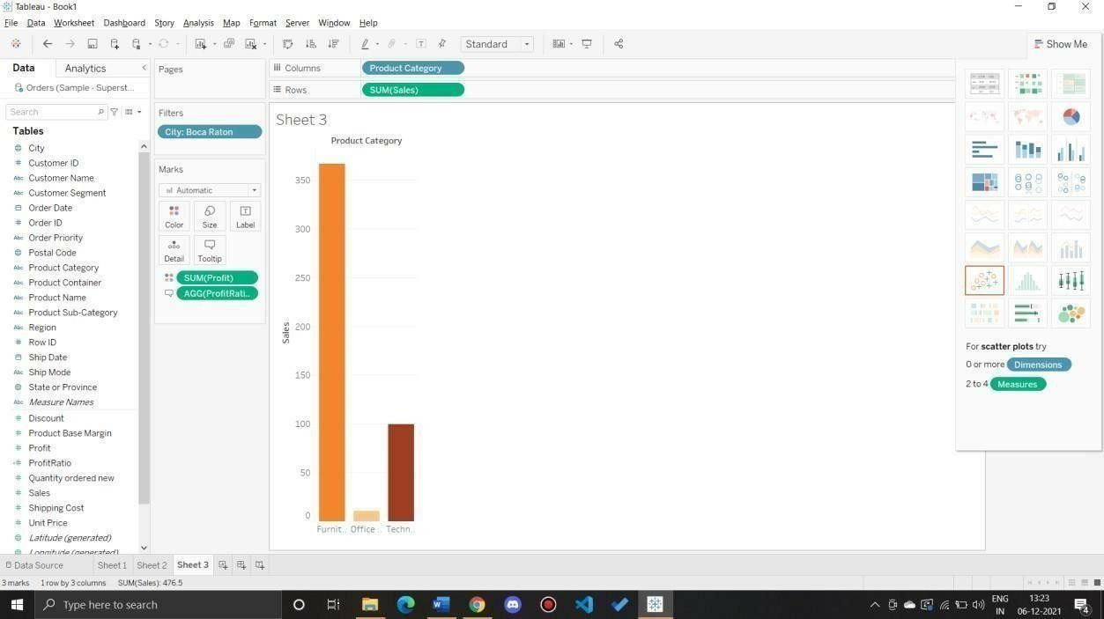

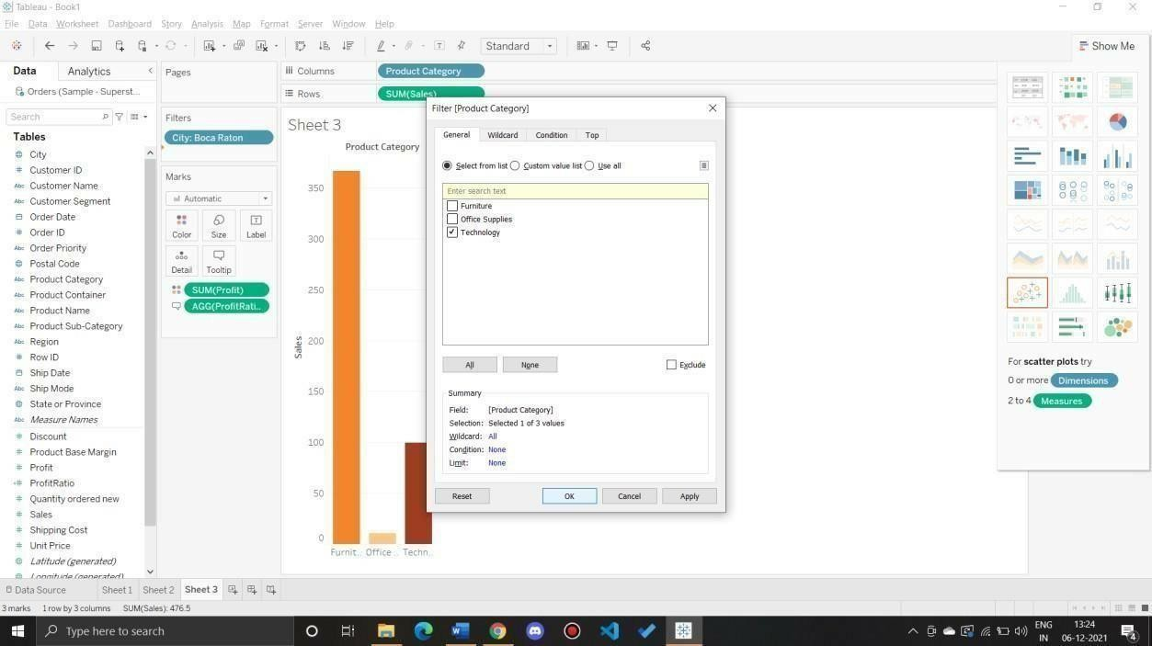

Q6:WhichProductDepartmenthasthehighestShippingCosts?NametheDepartmentand cost.

*Packedbubblechartshowing eachProductDepartmentasacoloredbubble*.

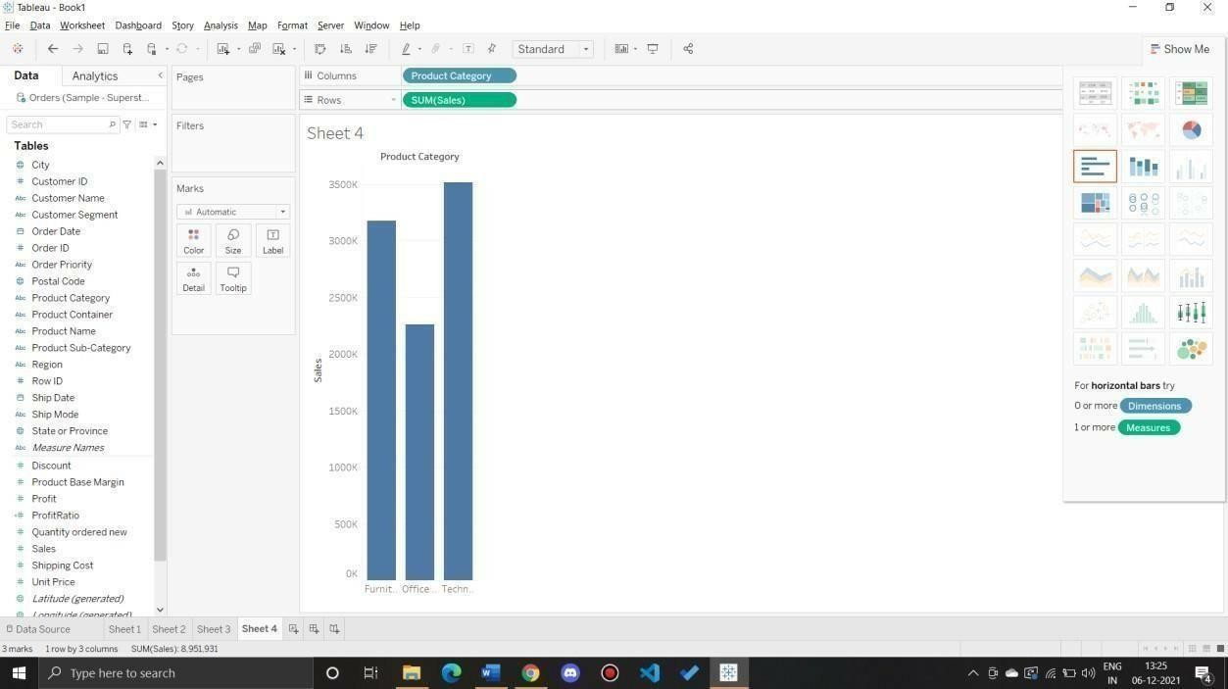

* 1. UseShippingCostto displaythesizeofeachbubble

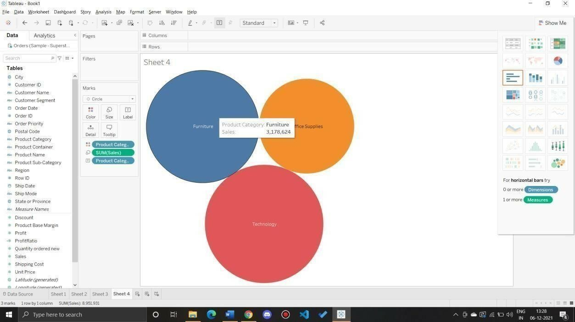

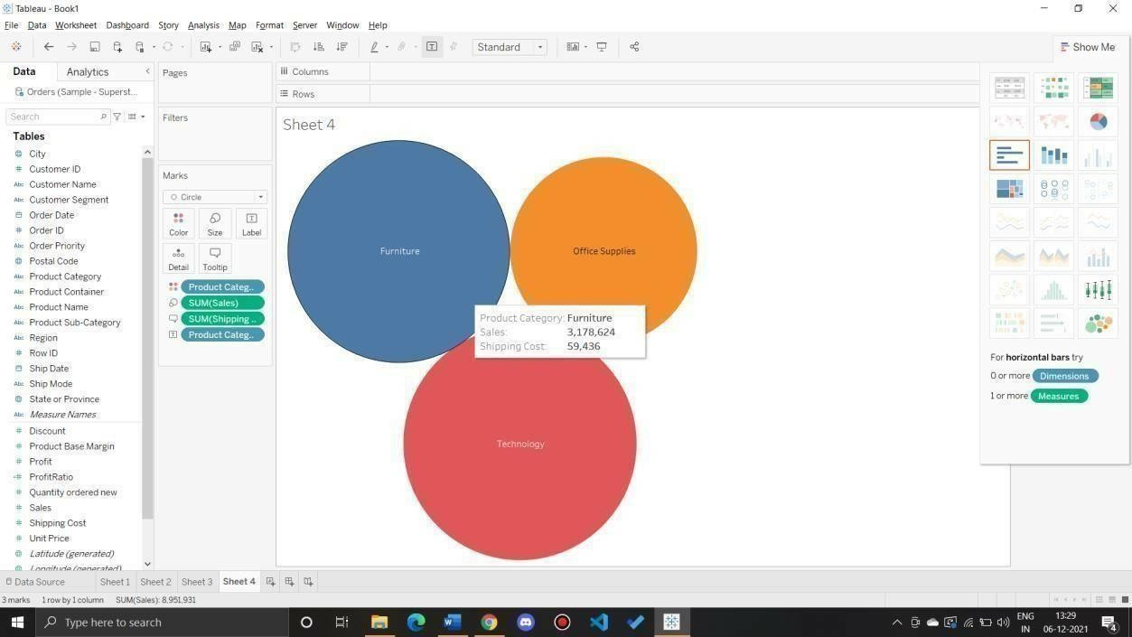

Q7:UsethesamevisualizationcreatedforQuestion#6.WhatwastheshippingcostofOfficeSuppliesforXerox1 905intheHomeCustomerSegmentinCambridge?

Ans:Applyfiltersasper requirement

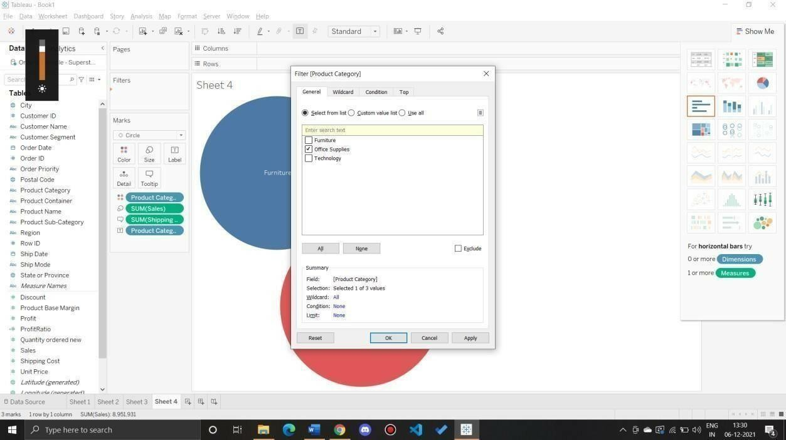

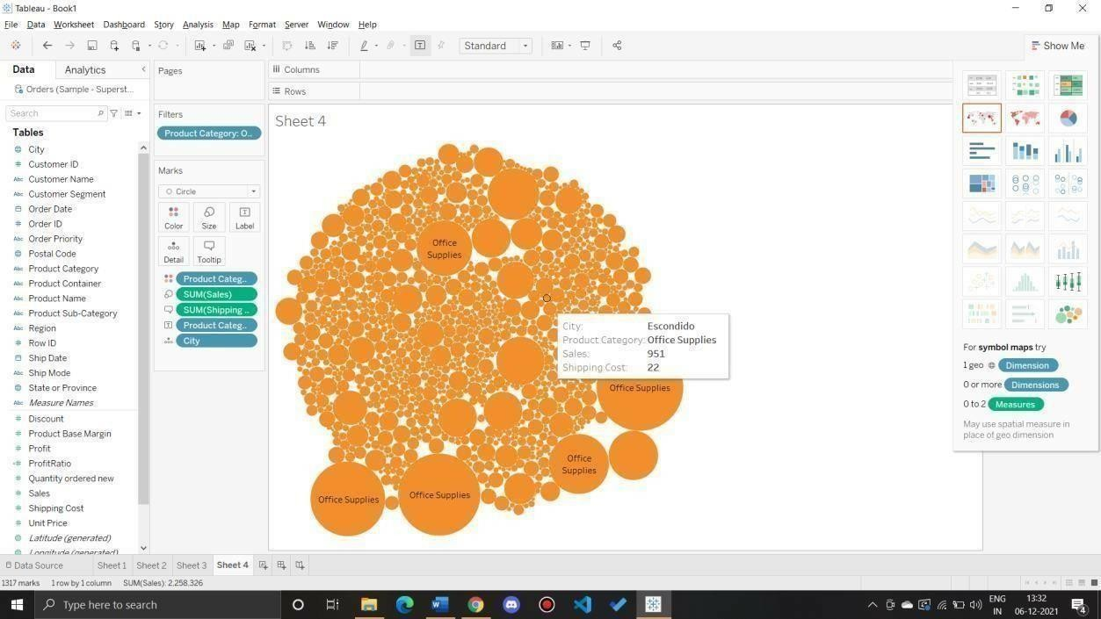

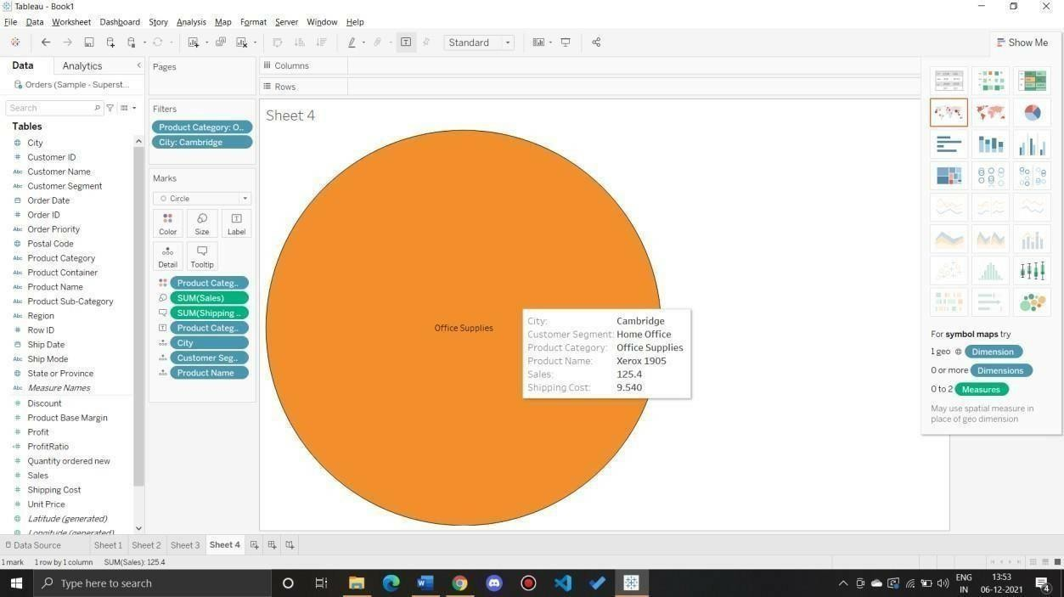

PreparingMaps

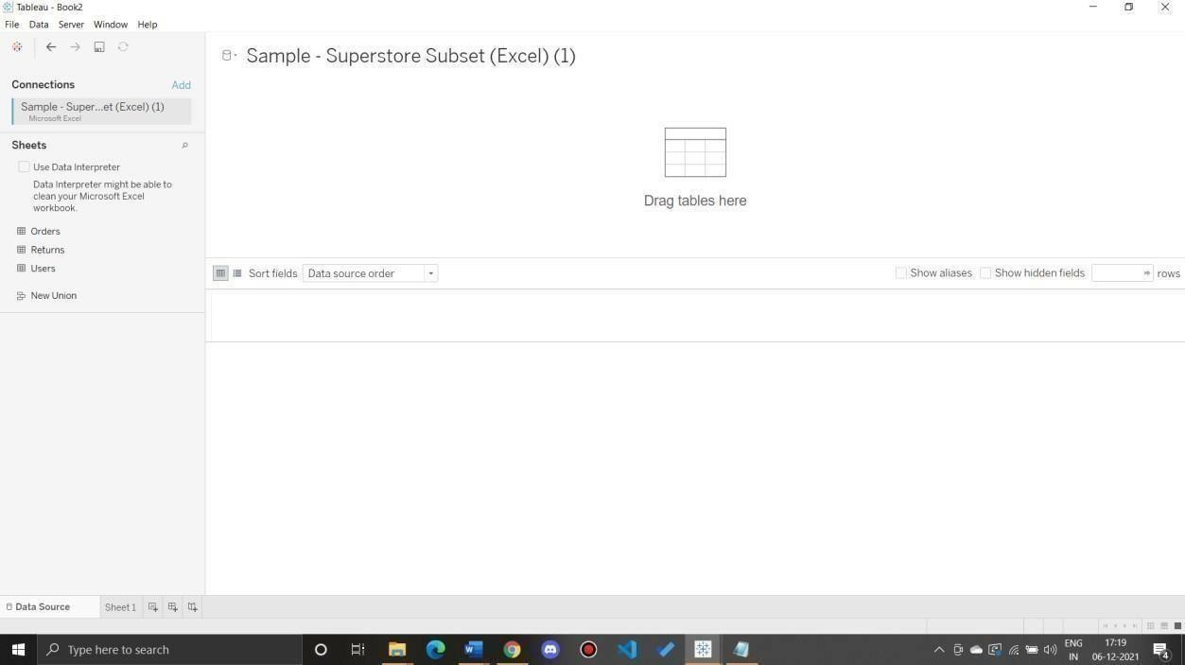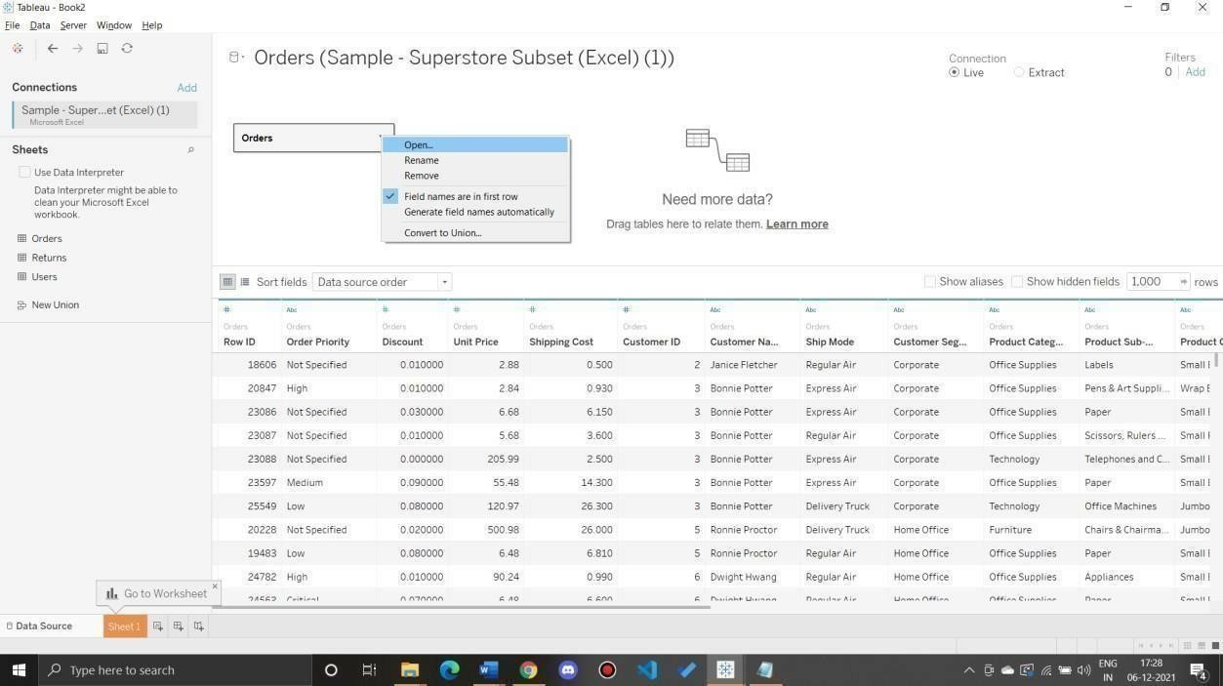Data SetforthisLabSample-Superstore Q1:PrepareaGeographicmaptoshowsalesineachstate. Ans: ***a)***Connecttodataset

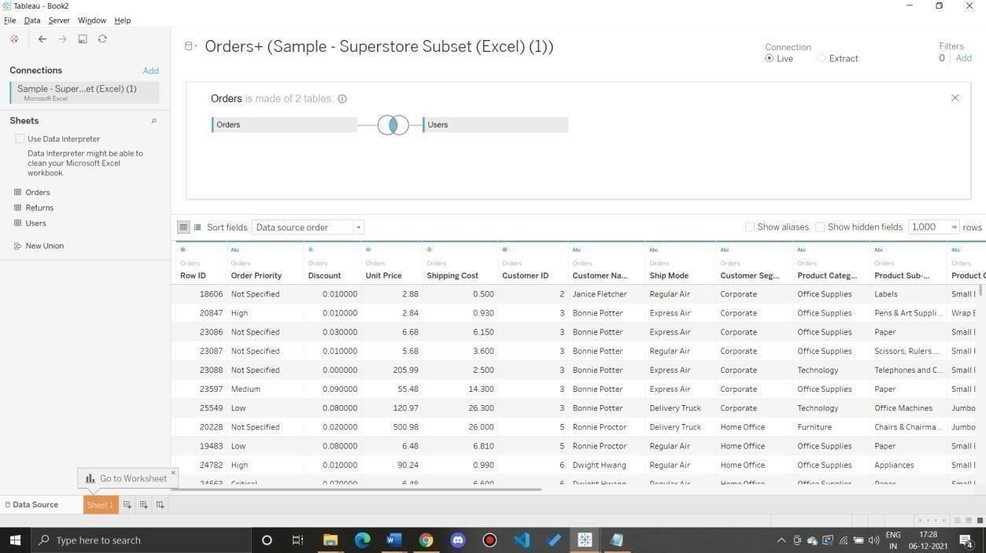

* 1. CreateaGeographicHierarchy
     1. IntheDatapane,right-clickthegeographicfield, Country,andthenselectHierarchy>CreateHierarchy.
     2. In the Create Hierarchy dialog box that opens, give the hierarchy a name, such as MappingItems,and thenclick OK.
     3. AtthebottomoftheDimensionssection,theMappingItemshierarchyiscreatedwiththe Countryfield.
     4. IntheDatapane,dragtheStatefieldtothehierarchyandplaceitbelowtheCountryfield.
     5. Repeatstep3forthe CityandPostalCodefields.

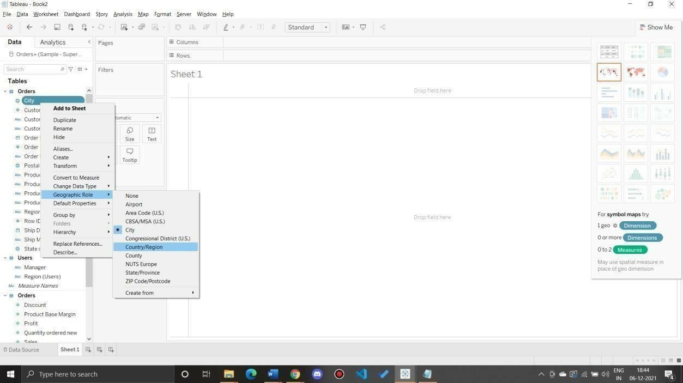

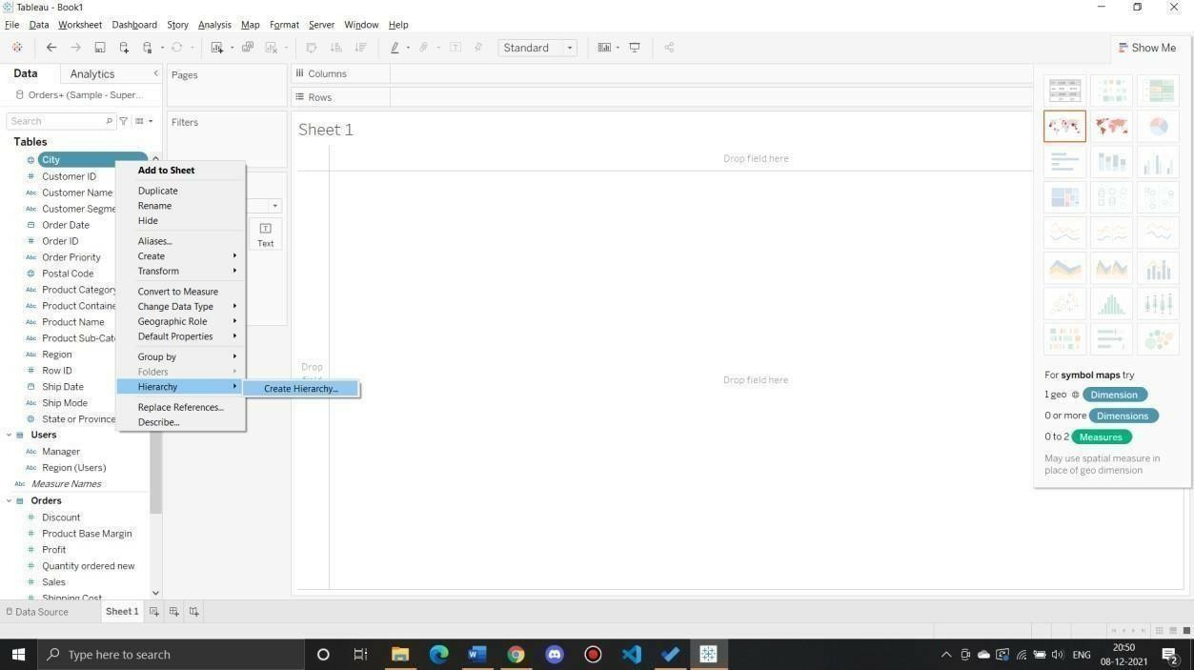

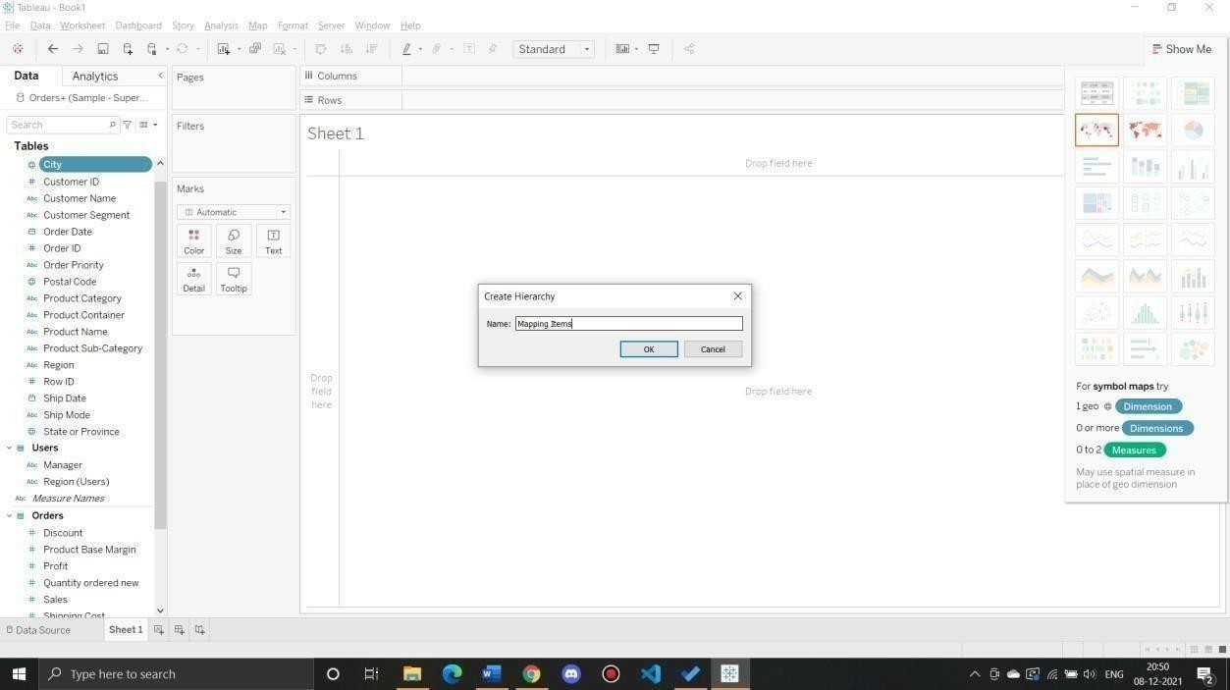

* 1. Buildabasicmap 1)IntheDatapane, double-clickCity**.

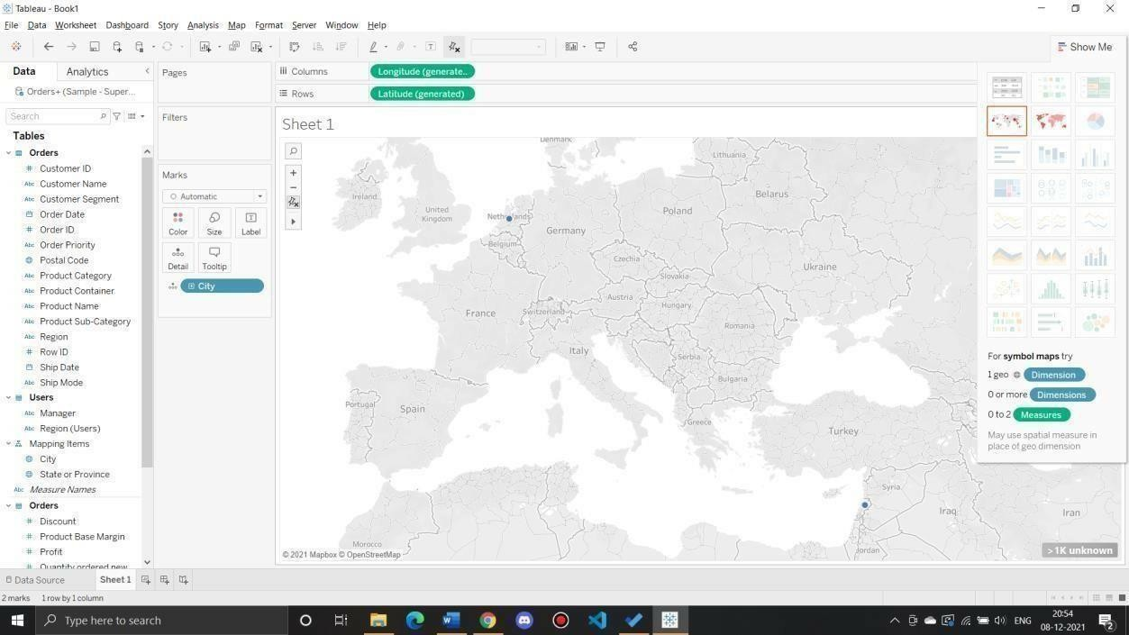

* 1. Addvisual detailAddcolor

FromMeasures,dragSalestoColorontheMarkscard.

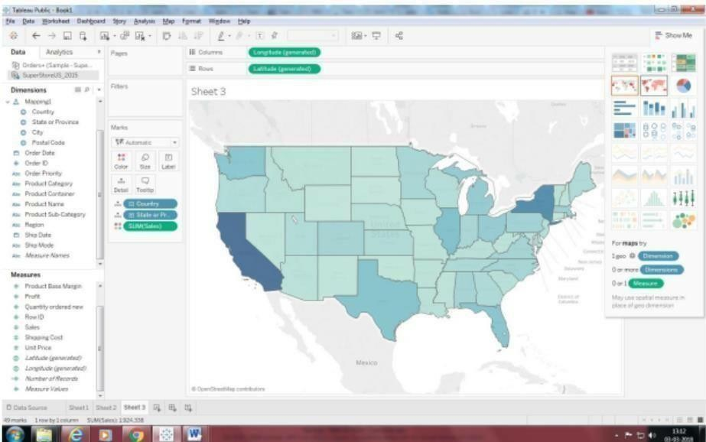

Addlabels

1. FromMeasures,dragSalestoLabelontheMarkscard.

Eachstateislabeledwith sumofsales. Thenumbersneedalittlebitofformatting,however.

1. IntheData pane,right-clickSales and selectDefaultProperties> Number Format.
2. IntheDefaultNumberFormatdialogboxthatopens,selectNumber(Custom),andthendothef ollowing:

* ForDecimalPlaces,enter0.
* ForUnits,selectThousands(K).
* ClickOK.

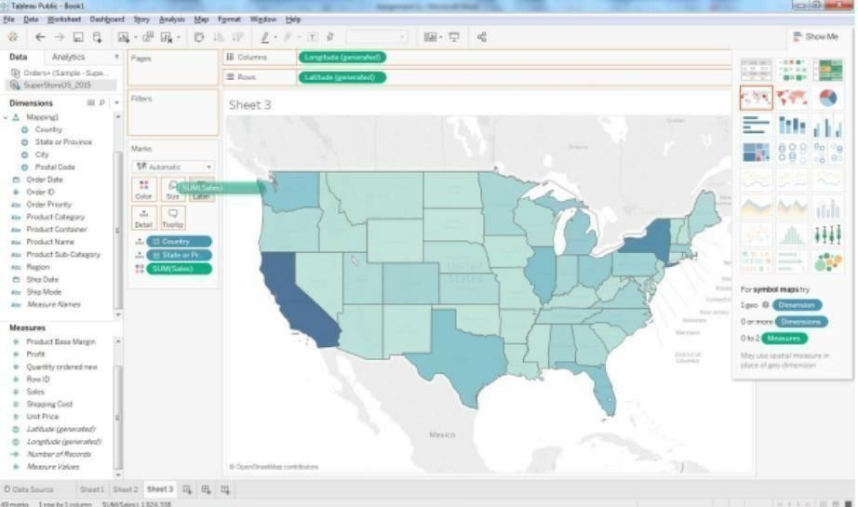

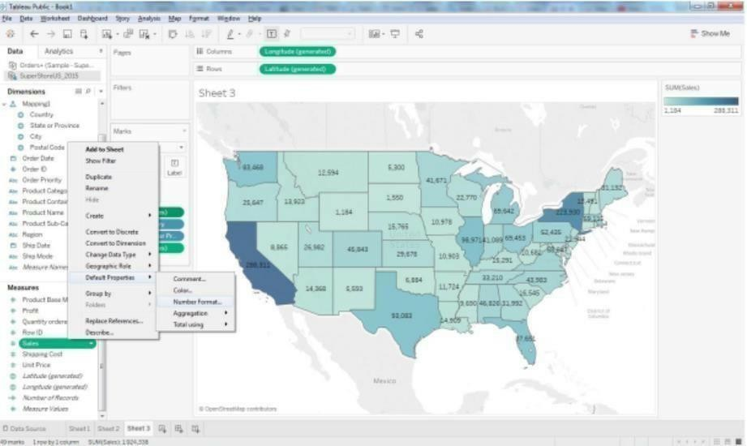

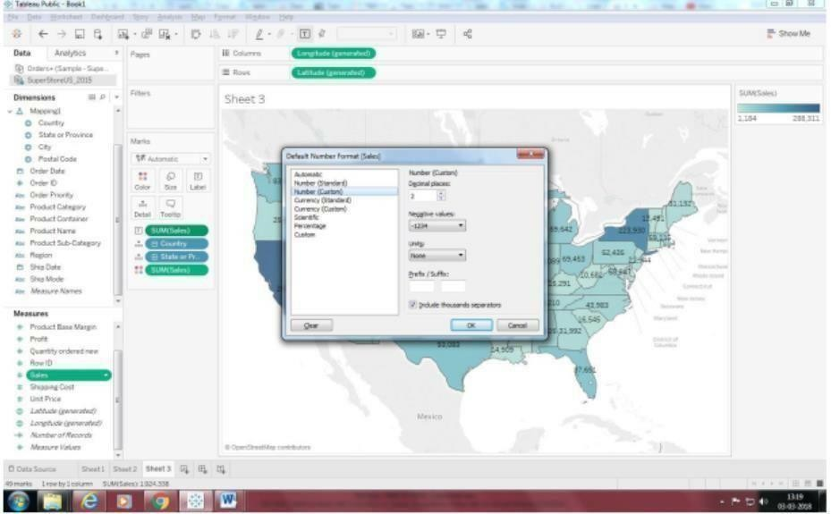

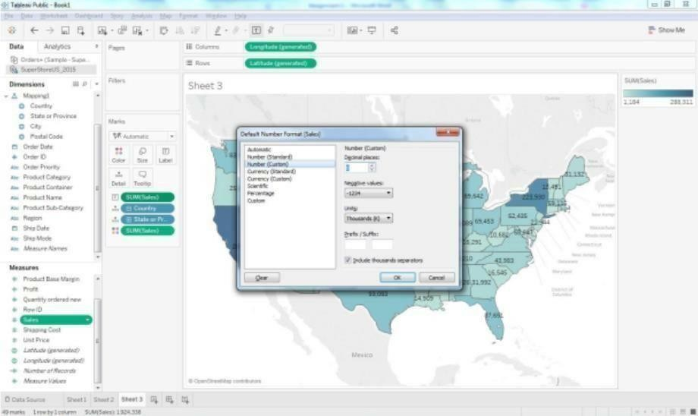

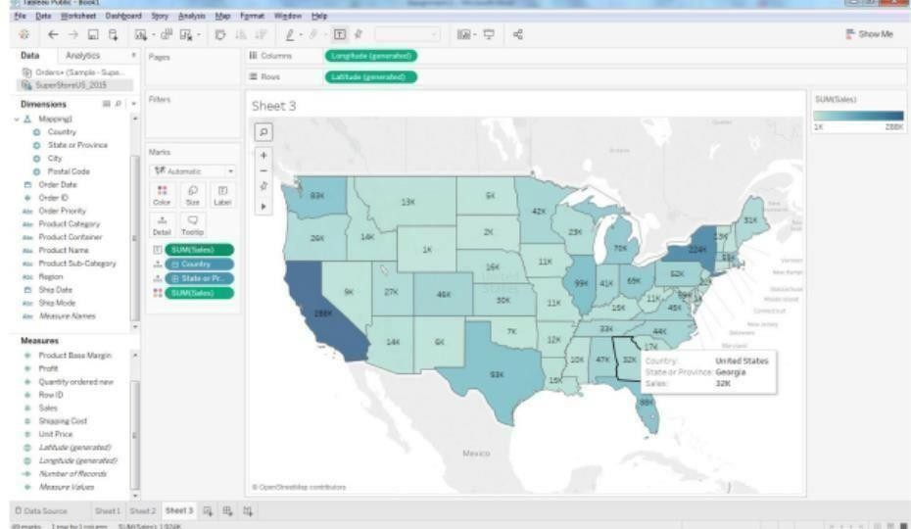

Q2: ShowProfitRatioofeachstateastooltip onmap

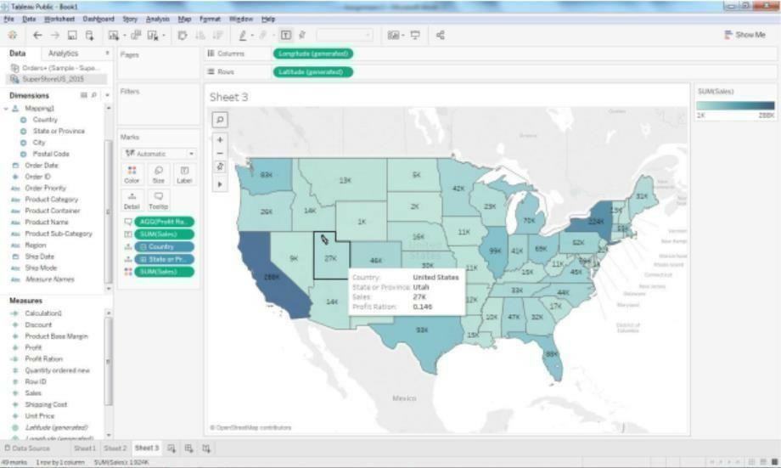

Q3:ShowProfitratioforGripEnvelopproducts

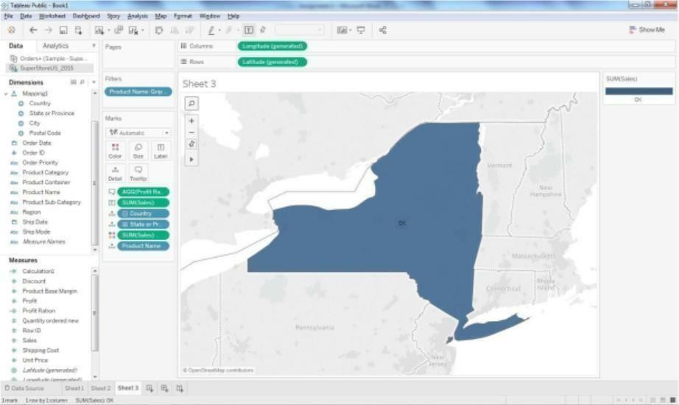

Q4:Inthetechnologyproductcategorywhichunprofitablestateissurroundedbyonlyprofitablestates.

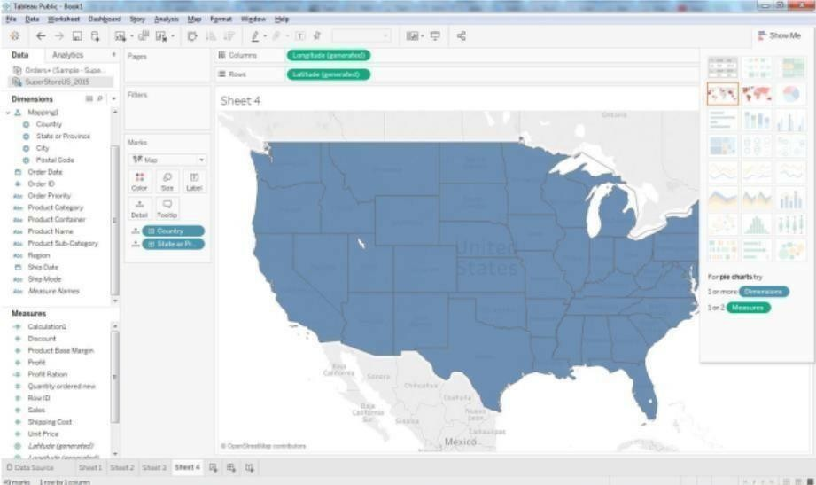

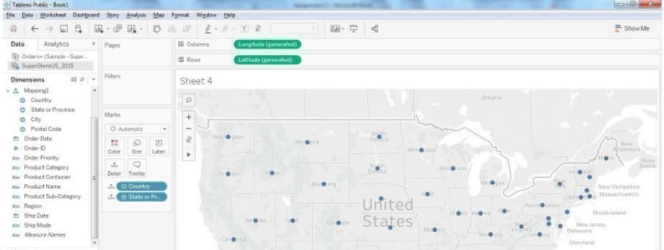

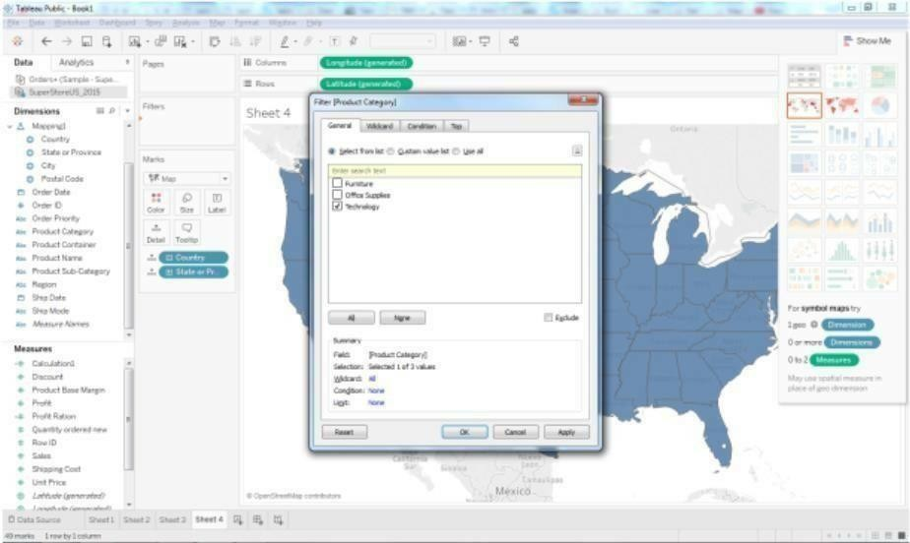

selectintechnology.

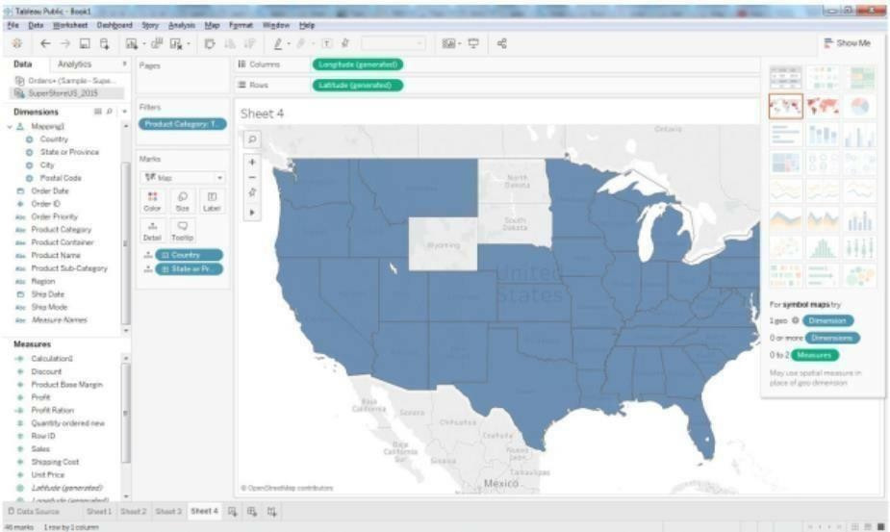

NowDragtheprofitmeasuretocolormark

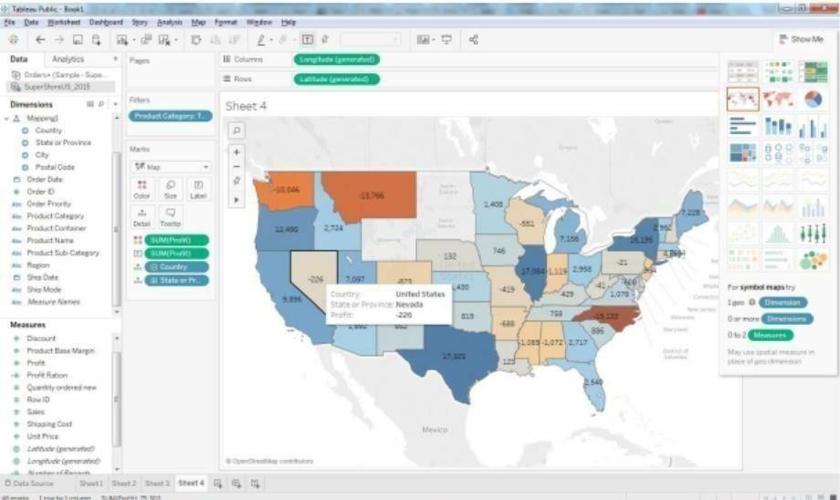

AddprofitLabel. NowwecanseeNevadaStateissurroundedbyprofitablestates.

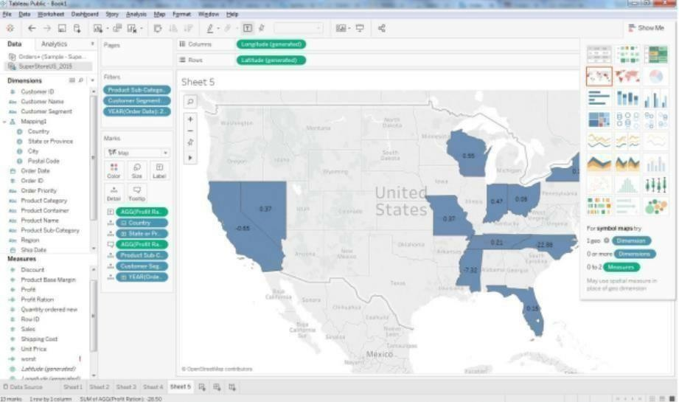Q5:WhichstatehastheworstGrossProfitRatioonEnvelopesintheCorporateCustomerSegmentthat wereShipped in 2015?

### PreparingReports

**DataSet**:Superstore

* 1. Prepareareportshowingproductcategorywisesales

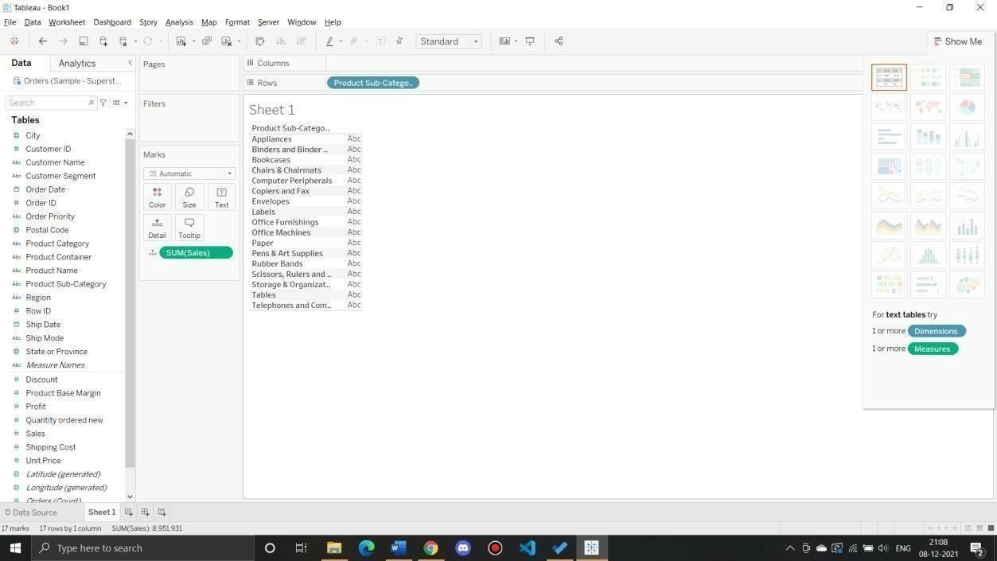

* 1. Reportshowingregionwiseproductwisesales

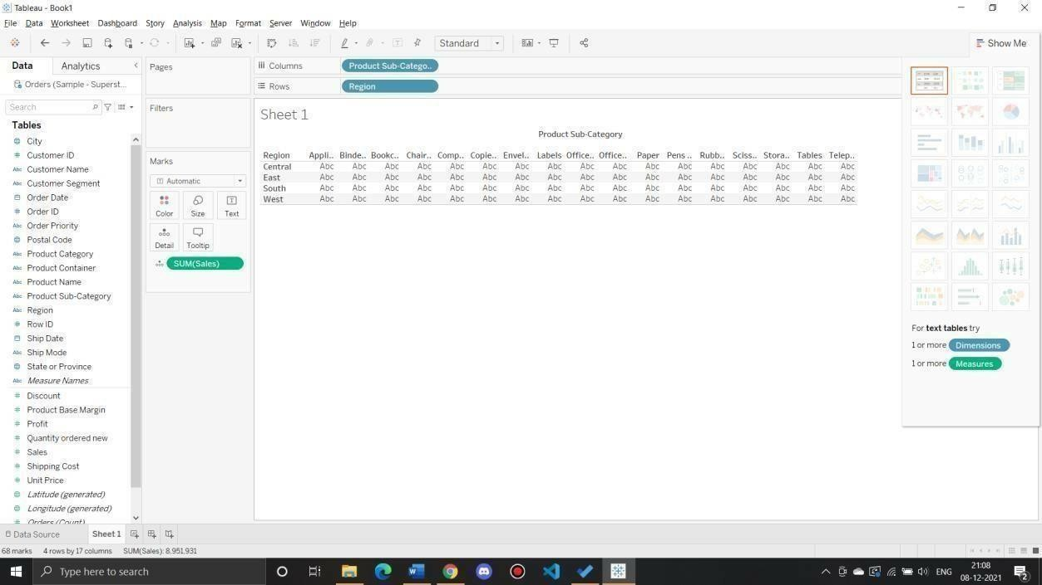

* 1. Reportshowingstatewisesales

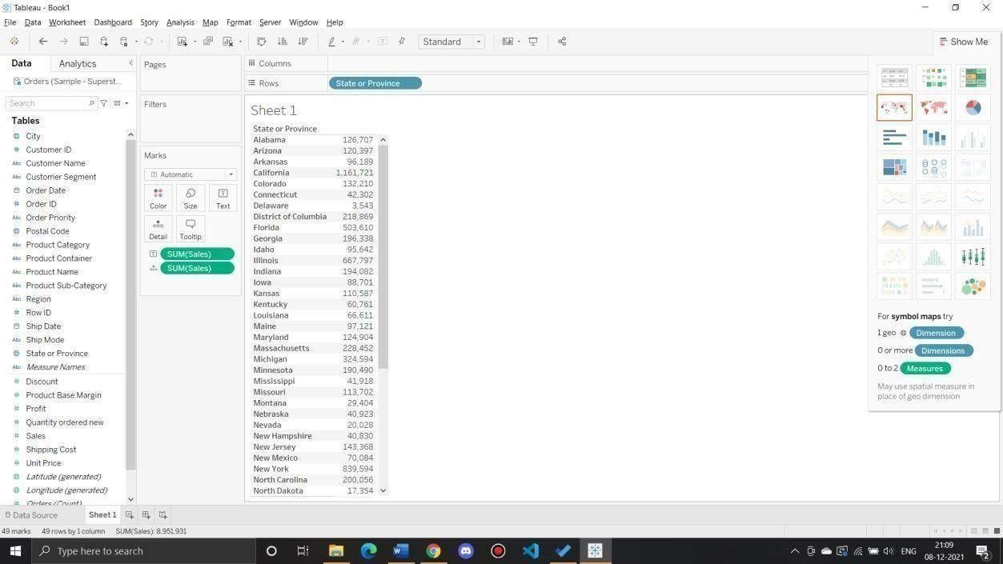

* 1. WhatisthepercentoftotalSalesforthe‘HomeOffice’CustomerSegmentinJulyof2014?

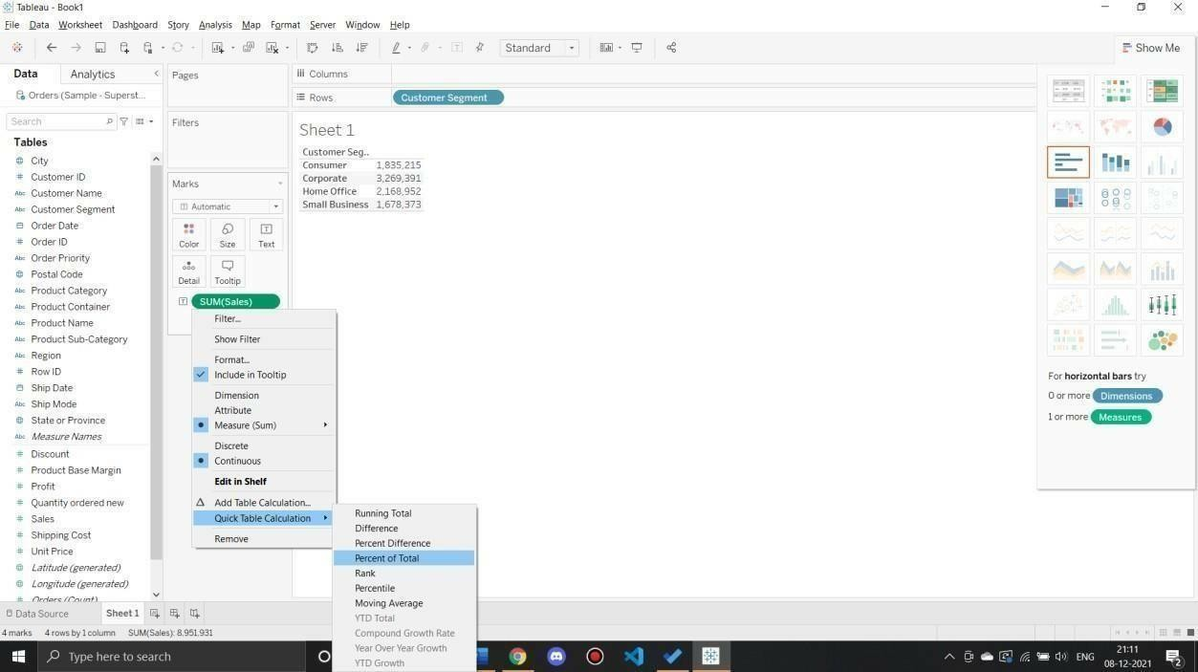

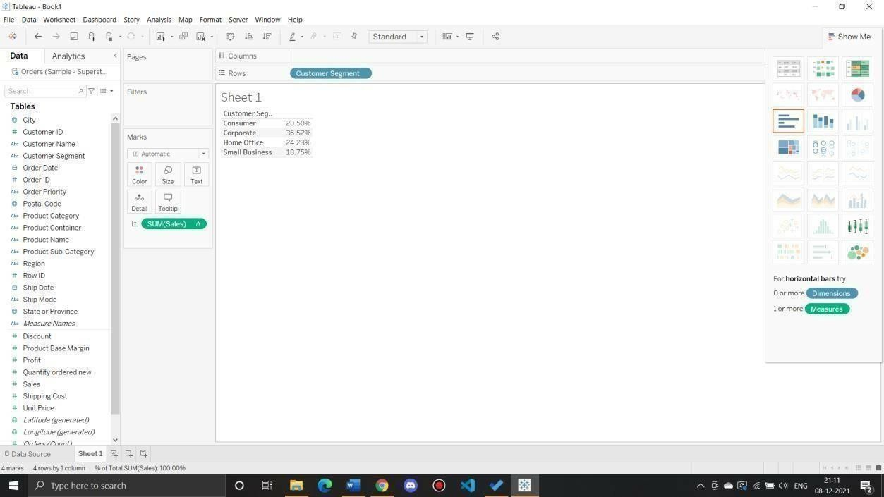

* 1. Findthetop10ProductNamesbySaleswithineachregion.Whichproductisranked#2inb oththeCentral&Westregions in2015?

Drag “Product Name” dimension from data pane window to Row Shelf and then add an “order Date”on Filter shelf and select “Year” of Order date as 2015.After that put region on Filter shelf and select “Central”and“West”checkbox.Also,putacopyofregiontotheColumnshelfaswell.

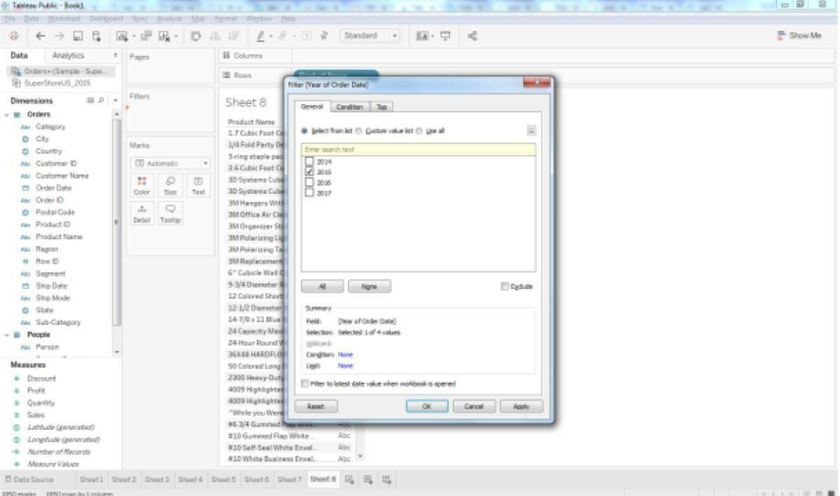

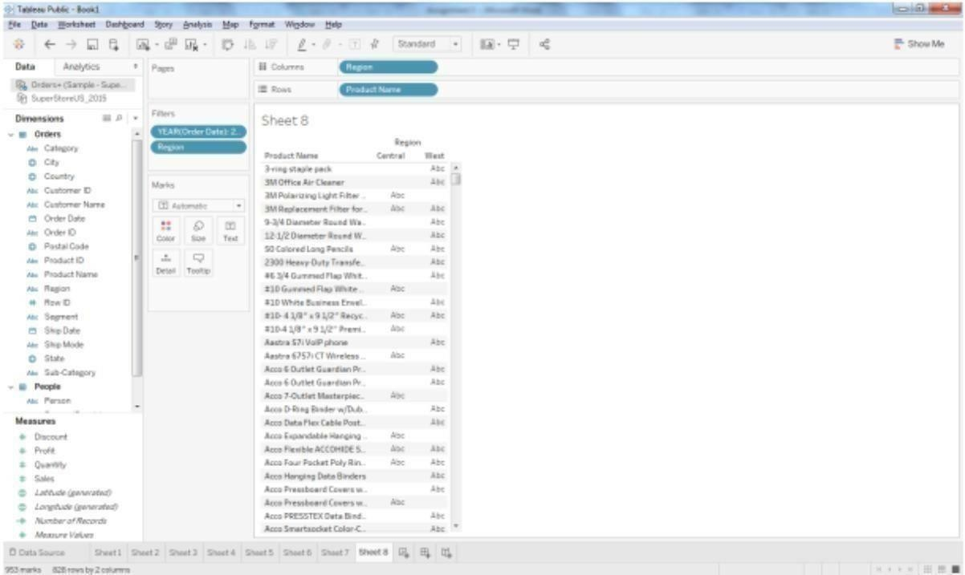

DragaSalesmeasuretothetextlabel.SoforgettingtheTop10“productname”bysales,weneedtoaddthe“Produ ctname”onFilter shelf.OncetheFilterPopupisopen,Select “TOP”tab>ByField>Top10bySum(Sales).

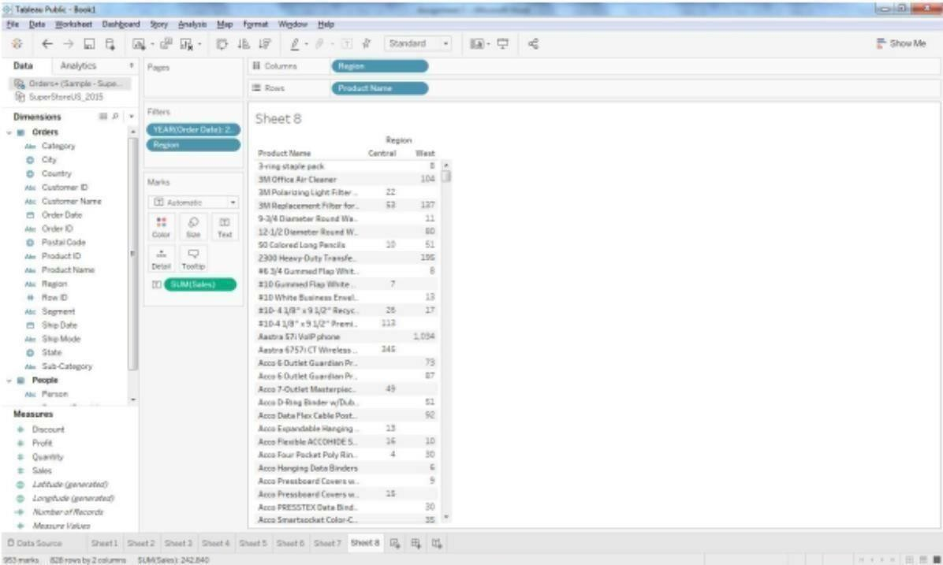

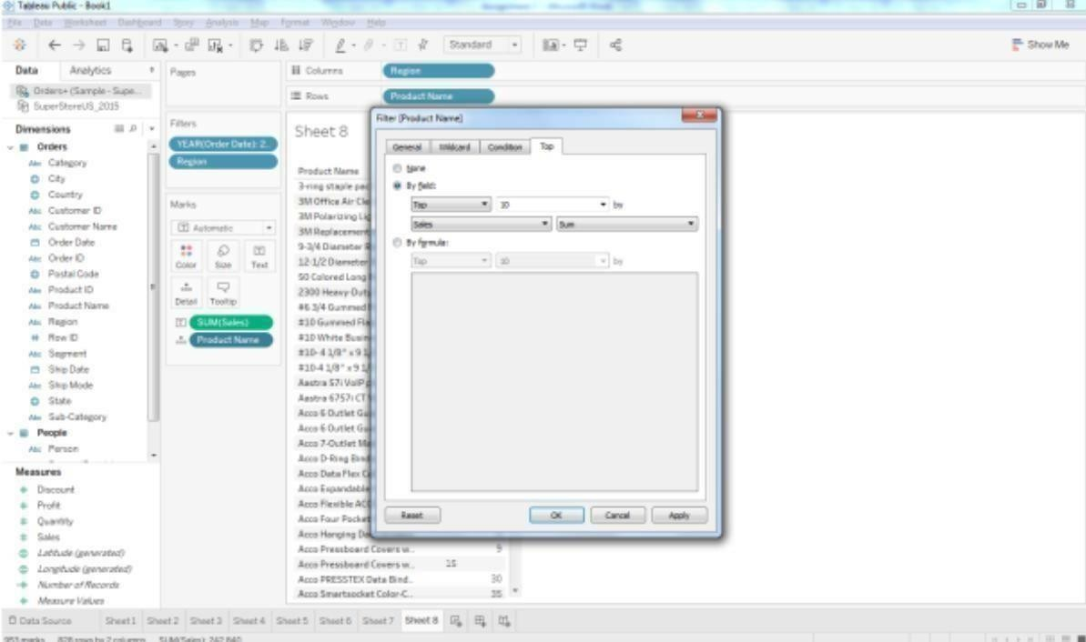

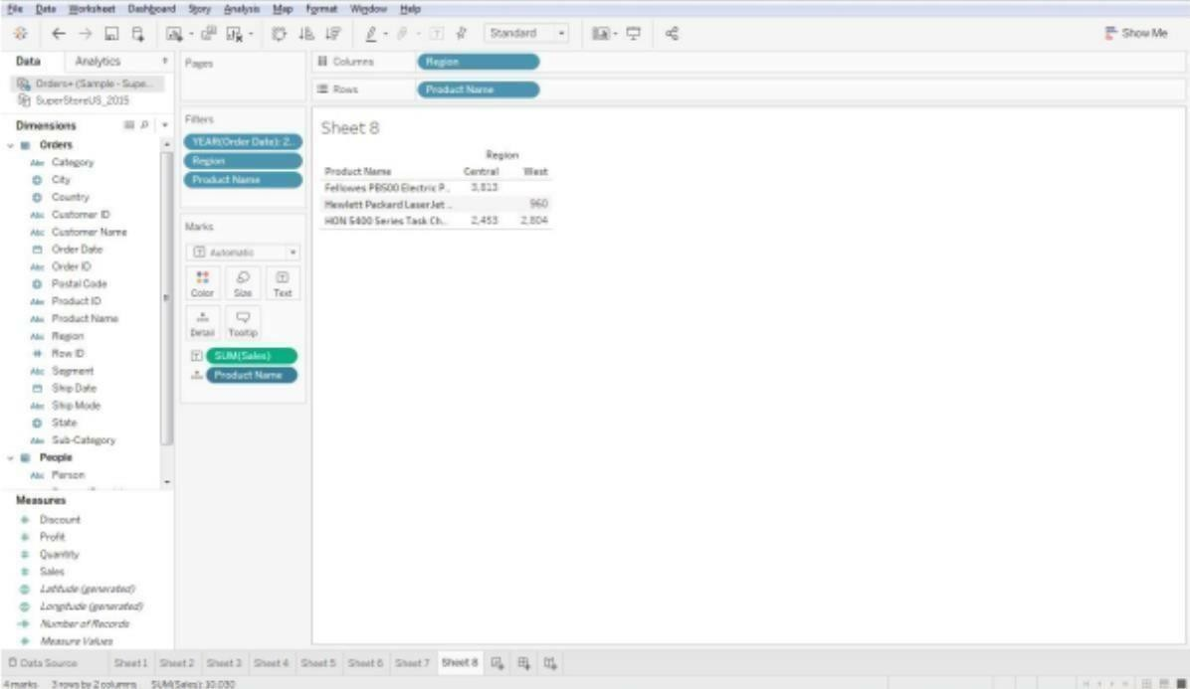

RightclickontheaggregatedSalesmeasureandclickonarrowsignthenselectQuickTableCalculation

>Rank.AsthedefaultaddressingisTableacross,pleasechangeitintoTableDown(Computeusing

->Table Down).

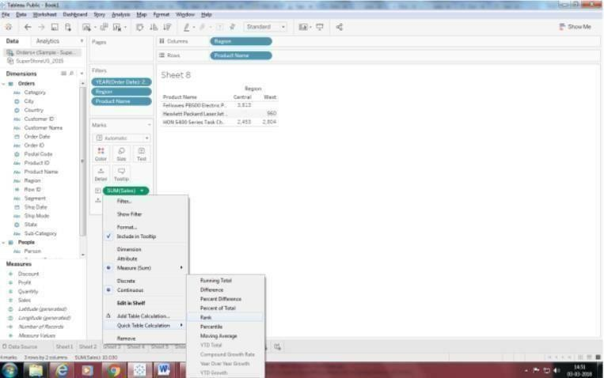

*96*